

**Kanku E-Commerce ( Beauty Product Website )**

A PROJECT REPORT

SUBMITTED IN PARTIAL FULFILLMENT OF THE REQUIREMENT FOR THE AWARD OF THE DEGREE OF

**Bachelors in Computer Application TO**

**RK UNIVERSITY, RAJKOT**

**SUBMITTED BY**

Name of Student Enrollment No.

**Ayush Sangtani 21FOTCA11120**

**Drashti Makadiya 21FOTCA11227**

**UNDER THE GUIDANCE OF**

**Pankti Kadivar Dr.Paresh Tanna**

Assistant Professor, Professor(HOD),

RK University, RK University,

RAJKOT RAJKOT



**SCHOOL OF ENGINEERING,**

**RKUNIVERSITY, RAJKOT**



**DECLARATION**

We here by certify that we are the sole authors of this project work and that neither any part of this project work nor the whole of the project work has been submitted for a degree to any other University or Institution. We certify that, to the best of our knowledge, our project work does not infringe upon anyone’s copyright nor violate any proprietary rights and that any ideas, techniques, quotations, or any other material from the work of other people included in our project document, published or otherwise, are fully acknowledged in accordance with the standard referencing practices. We declare that this is a true copy of our project work, including any final revisions, as approved by our project review committee.

**Project Team**

**Ayush Sangtani (21FOTCA11120)**

**Drashti Makadiya (21FOTCA11227)**

Date: - 11/10/2023

Place: - RK University

**TABLE OF CONTENTS**

|  |  |
| --- | --- |
| **TITLE** | **PAGE NO.** |
| **ACKNOWLEDGEMENT** | 5 |
| **ABSTRACT** | 6 |
| **1. INTRODUCTION** | 8 |
| **1.1 PROJECT SUMMARY** | 8 |
| **1.2 PURPOSE** | 11 |
| **1.3 HTML, CSS, PHP** | 13 |
| **2. PROJECT MANAGEMENT** | 15 |
| **2.1 PROJECT PLANNING AND SCHEDULING** | 15 |
| **2.1.1 PROJECT DEVELOPMENT APPROACH** | 15 |
| **2.1.2 PROJECT PLAN** | 17 |
| **2.1.3 SCHEDULE REPRESENTATION** | 19 |
| **3. SYSTEM REQUIREMENTS STUDY** | 21 |
| **3.1 USER CHARACTERISTICS** | 21 |
| **3.2 HARDWARE** | 22 |
| **4. SYSTEM ANALYSIS** | 24 |
| **4.1 STUDY OF CURRENT SYSTEM** | 24 |
| **4.2 PROBLEM & WEAKNESS OF CURRENT SYSTEM** | 26 |
| **4.3 FEASIBILITY STUDY** | 28 |
| **4.4 REQUIREMENT VALIDATION** | 30 |
| **4.5 FUNCTION SYSTEM** | 32 |
| **4.5.1 E-R DIAGRAM** | 32 |
| **4.5.2 USE CASE DIAGRAM** | 33 |
| **4.5.3 DATA FLOW DIAGRAM** | 33 |
| **4.6 DATA MODELING** | 35 |
| **4.7 MAIN MODULES OF NEW SYSTEM** | 35 |
| **5. SYSTEM DESIGN** | 36 |
| **5.1 FLOW CHART** | 36 |
| **6. TESTING** | 37 |
| **6.1 TEST PLAN** | 37 |
| **6.2 TESTING STRATEGY** | 39 |
| **6.3 TESTING METHODS** | 42 |
| **6.4 TESTING CASES** | 44 |
| **7. DATA DICTIONARY** | 46 |
| **8. SCREEN SHOTS** | 49 |
| **9. LIMITATION & FUTURE ENHANCEMENT** | 61 |
| **10. CONCLUSION AND DISCUSSION** | 64 |
| **11. REFERENCES** | 64 |

**ACKNOWLEDGEMENT**

The success and final outcome of this project required a lot of guidance and assistance from many people and We are extremely fortunate to have got this all along the completion of my project work. Whatever we have done is only due to such guidance and assistance and we would not forget to thank them.

We respect and thank **RK University** for giving us an opportunity to do the project work in 5BCA and providing us all support and guidance which make us complete the project on time. We are extremely grateful to him for providing such a nice support and guidance though he had busy schedule managing the company affairs.

We also thank our internal project guide, **Prof. Pankti Kadivar, RK University Rajkot,** for his guidance and suggestions during this project work.

We are thankful to and fortunate enough to get constant encouragement, support and guidance from all Teaching staffs of Department of Bachelor of Computer Application which helped us in successfully completing our project work. Also, we would like to extend our sincere regards to all the non-teaching staff of department for their timely support.

**ABSTRACT**

The "Kanku" PHP e-commerce website is a dynamic online platform specializing in the sale of high-quality beauty products under the many brands like lakme, swiss beauty etc. The website offers customers a seamless and user-friendly experience to explore, select, and purchase a diverse range of beauty products.

**Key Features:**

**1. Product Catalog:** "Kanku" proudly presents an extensive catalog of beauty products, including cosmetics, beauty products, tools & brush and more. Each product listing features detailed descriptions, high-resolution images, and transparent pricing information.

**2. User Accounts:** Customers can create personalized accounts that store their order, shipping information, and payment preferences. This simplifies the checkout process for returning customers and encourages customer loyalty.

**3. Secure Shopping Cart and Checkout:** The website incorporates a secure shopping cart that allows users to add and manage selected items before proceeding to the checkout process. The checkout process is streamlined and secure, ensuring the confidentiality of customer data and payment details.

**4. Responsive Design:** The website is designed with a responsive layout, adapting seamlessly to various devices including desktops, tablets, and smartphones. This ensures that customers can shop conveniently from any device.

**5. Special Offers and Promotions:** The site showcases special promotions, discounts, and seasonal offers prominently, enticing customers to explore new products and take advantage of savings.

The "Kanku" website is committed to offering an extensive selection of beauty products while prioritizing a secure, user-centric, and engaging shopping experience. Its intuitive features, informative content, and responsive design underscore its dedication to enriching the beauty shopping journey for its customers.

Our user-friendly website is designed with your convenience in mind. Browse seamlessly, explore detailed product information, and make secure purchases with ease. We prioritize your satisfaction, offering multiple payment options and a commitment to data security.

At "Kanku," we don't just sell beauty products; we empower confidence and self-expression. Elevate your beauty ritual with products that make you feel your best, and let "Kanku" be your trusted partner in your journey to radiant beauty.

Welcome to a world of beauty, where every product tells a story and enhances your natural allure. Explore "Kanku" today and experience the transformative power of beauty.

**INTRODUCTION**

**PROJECT SUMMARY**

The "Kanku" website is a dynamic e-commerce platform built using PHP technology, dedicated to providing users with a seamless and engaging shopping experience focused on high-quality beauty products. this platform offers an extensive range of beauty products, catering to individuals looking to enhance their personal beauty routines.

**Key Features and Objectives:**

* **Product Diversity:** "Kanku" boasts a comprehensive catalog of beauty products, including skincare essentials, cosmetics, and more. Our objective is to offer a diverse array of products to meet various beauty needs.
* **User-Friendly Interface:** Our website is designed with an intuitive and user-centric layout, ensuring easy navigation. Customers can explore products effortlessly, add them to their carts, and proceed to a secure checkout.
* **Personalization:** User accounts enable customers to create profiles, manage orders, and store shipping preferences, fostering a personalized shopping experience.
* **Product Information:** Each product is accompanied by detailed descriptions, high-resolution images, and user reviews, enabling informed purchasing decisions.
* **Responsive Design:** The website is responsive across various devices, enhancing accessibility and usability for users on desktops, tablets, and smartphones.
* **Promotions and Savings:** Special offers and promotions are highlighted, encouraging users to explore new products and take advantage of cost-saving opportunities.

**Impact and Vision:**

The "Kanku" website aims to be your trusted online destination for beauty product solutions. By combining an aesthetically pleasing interface with seamless functionality, secure transactions, and informative content, we aim to contribute to your beauty and skincare needs.

**Future Development:**

* **Expanded Product Range:** Continuously expand and diversify your product offerings to cater to a broader audience and stay ahead of beauty trends. Consider introducing niche products or exclusive lines.
* **Personalization:** Implement personalized product recommendations and beauty routines based on user preferences and past purchases to enhance the shopping experience.
* **Virtual Try-On:** Integrate virtual try-on technology for makeup and skincare products, allowing customers to visualize how products will look on them before making a purchase.
* **Subscription Services:** Offer subscription boxes or services for customers who want regular deliveries of their favorite beauty products. This can help build customer loyalty and ensure recurring revenue.
* **Beauty Blog or Content Hub**: Create a beauty blog or content hub featuring articles, tutorials, and videos related to beauty tips, trends, and product reviews to engage and educate your audience.
* **Mobile Wallet Integration:** Integrate mobile wallet payment options and explore emerging payment technologies to provide even more convenient checkout experiences.
* **Mobile App:** Develop a mobile app for "Kanku" to provide a dedicated and convenient shopping experience for mobile users.
* **AI Chatbots:** Implement AI-powered chatbots to provide real-time customer support, answer common queries, and assist with product recommendations.

In conclusion, the "Kanku" website is dedicated to providing you with a convenient, secure, and fulfilling online shopping experience for beauty products. As we continue to innovate, we aim to redefine the way you engage with beauty products in the digital age.

Explore "Kanku" and elevate your beauty routine today!

**PURPOSE**

The purpose of the "Kanku" PHP e-commerce website is to establish an online platform dedicated to meeting individuals' beauty and skincare needs. the website is designed to provide users with convenient access to a wide array of high-quality beauty products, facilitating a holistic approach to beauty and skin care.

**Key Purposes:**

1. **Beauty Empowerment:** The primary purpose of "Kanku" is to empower individuals by offering a curated selection of beauty products that enhance their natural beauty and boost their self-confidence. We believe that beauty is a means of self-expression and care.
2. **Convenience and Accessibility:** aims to offer customers a convenient and accessible way to explore, select, and purchase beauty products from the comfort of their homes. This convenience is instrumental in encouraging individuals to prioritize their beauty and skincare routines.
3. **Enhancing Beauty and Confidence:** By curating a diverse range of beauty products, the website empowers users to discover items that enhance their physical appearance, boost self-confidence, and contribute to overall well-being.
4. **Daily Beauty Rituals:** "Kanku" encourages users to establish daily beauty rituals by offering products that seamlessly integrate into their skincare routines. This can lead to positive beauty changes and a heightened sense of skin-care.
5. **Quality Products:** By offering a carefully selected range of products, the website builds trust with customers. Users can rely on the platform to provide products that meet high standards of quality and effectiveness.
6. **Encouraging Self-Investment:** "Kanku" conveys the importance of self-investment through beauty and skin-care. It encourages users to prioritize their personal grooming and well-being, fostering a positive mindset.
7. **Modern Digital Shopping:** In an era dominated by online shopping, the website offers a modern, user-friendly interface that aligns with consumers' digital shopping habits. This positions "Kanku" to tap into the burgeoning e-commerce market.
8. **Revenue Generation:** Ultimately, the website seeks to drive sales and generate revenue by providing users with beauty products that align with their skin-care aspirations and beauty preferences.

In summary, the "Kanku" beauty product website's purpose is to offer a user-centric platform where individuals can access, explore, and purchase high-quality beauty products, enriching their beauty routines and fostering self-confidence and well-being. It embodies the fusion of technology, education, and premium products to encourage users to prioritize beauty and skin-care in their lives.

**HTML, CSS, PHP**

**HTML**, which stands for Hyper Text Markup Language, is the standard language used to create web pages. It's the backbone of almost every website on the internet. **HTML** provides the structure and content of a webpage, defining elements such as headings, paragraphs, images, links, forms, and more.

**CSS**, or Cascading Style Sheets, is a stylesheet language used in web development to describe the visual presentation and layout of HTML documents. It is a fundamental technology that allows developers to control how web content is displayed on various devices and screen sizes.

**CSS** enables you to define the colors, fonts, spacing, positioning, and other stylistic aspects of HTML elements. It provides a way to separate the structure (HTML) and content of a webpage from its design, which enhances maintainability and flexibility. With CSS, you can create consistent and appealing designs across your website.

**PHP**, which stands for Hypertext Preprocessor, is a server-side scripting language primarily used for web development. It's one of the most widely used languages for building dynamic web applications and websites. **PHP** code is executed on the web server, generating HTML that is then sent to the client's browser. Let's explore PHP in detail:

* **Server-Side Scripting:** PHP is a server-side scripting language, meaning it runs on the web server before the final HTML is sent to the client's browser. This allows for dynamic content generation and processing on the server.
* **Embedded within HTML:** PHP code is typically embedded directly within HTML files, making it easy to mix dynamic content with static content. PHP code is enclosed in <?php ... ?> tags.
* **Syntax and Variables:** PHP uses familiar programming constructs, such as variables, operators, conditionals, loops, and functions. Variable names in PHP start with a dollar sign ($) and are case-sensitive. PHP supports various data types, including integers, floating-point numbers, strings, arrays, objects, and more.
* **Functions:** PHP provides a vast standard library of built-in functions for various purposes, including string manipulation, date and time handling, file operations, and more. Developers can define their custom functions to encapsulate reusable code blocks.
* **Database Interaction:** PHP can connect to databases using extensions like MySQLi (MySQL Improved) or PDO (PHP Data Objects). Developers can execute SQL queries, fetch data, and perform database transactions using PHP.

**PROJECT MANAGEMENT**

**PROJECT PLANNING AND SCHEDULING**

* **PROJECT DEVELOPMENT APPROACH**

**1. Project Initiation:**

Requirements Gathering: Understand the project's goals, target audience, features, and functionalities. Define the scope of the project and create a detailed list of requirements.

Technology Selection: Confirm that PHP is the chosen backend language. Decide on the frontend technologies (HTML, CSS, JavaScript) and any additional frameworks or libraries.

**2. Planning:**

Project Timeline: Break down the development process into phases and estimate the time required for each phase. Create a project timeline with milestones and deadlines.

Resource Allocation: Assign tasks to team members or external resources based on their expertise. Determine roles and responsibilities.

Database Design: Plan the database structure, including tables for products, users, orders, category and any other necessary data.

**3. Design:**

User Interface Design: Create wireframes and mockups of the website's pages. Design the user interface with a focus on user experience and responsive design for various devices.

Database Schema: Develop the database schema based on the defined requirements. Decide on relationships between tables and optimize for efficient data storage and retrieval.

**4. Development:**

Frontend Development: Begin implementing the HTML, CSS, and JavaScript code based on the design. Ensure the user interface is interactive, user-friendly, and visually appealing.

Backend Development: Implement the PHP code to handle user authentication, product management, shopping cart, order processing, and other functionalities. Connect the backend with the database.

Integration: Integrate the frontend and backend components, ensuring proper communication between them. Implement features like user registration, login, and shopping cart functionality.

**5. Testing:**

Unit Testing: Test individual components and functions to ensure they work as expected.

Integration Testing: Test the interactions between different modules and components.

User Acceptance Testing (UAT): Invite a group of users to test the website and provide feedback. Identify and fix any issues or usability concerns.

Performance Testing: Check the website's performance under various conditions, including high traffic loads.

**6. Deployment:**

Hosting Setup: Choose a web hosting provider that supports PHP and meets your website's needs.

Database Deployment: Deploy the database to the chosen hosting environment.

Code Deployment: Upload the website's files to the server.

**7. Launch:**

Final Testing: Conduct a final round of testing to ensure everything is working correctly in the production environment.

Launch Plan: Plan the website's launch date and prepare any promotional materials or announcements.

**8. Post-Launch:**

Monitoring: Continuously monitor the website's performance, security, and user feedback.

Updates and Maintenance: Regularly update the website with new products, features, and improvements based on user feedback and changing business needs.

Marketing and Promotion: Implement marketing strategies to attract users and promote the website.

**9. Continuous Improvement:**

Gather Feedback: Encourage users to provide feedback and suggestions for improvement.

Data Analysis: Analyze user behavior and sales data to make informed decisions about future updates and enhancements.

Following this approach will help ensure a well-structured and successful development process for your PHP e-commerce Beauty Product Kanku Website. Keep in mind that flexibility is important, as adjustments and refinements may be necessary along the way.

* **PROJECT PLAN**

**1. Project Initiation:**

Define project scope, objectives, and goals.

Gather requirements for the e-commerce site's features and functionalities.

Choose the technology stack: PHP for backend, HTML/CSS/JS for frontend.

**2. Planning:**

Break down requirements into specific tasks.

Estimate time and resources needed for each task.

Create a Work Breakdown Structure (WBS) to organize tasks.

Develop a project timeline with milestones and deadlines.

Identify potential risks and develop risk mitigation strategies.

**3. Design:**

Create wireframes and mockups for the user interface.

Plan the database schema and relationships for products, users, orders, category etc.

Design the site's visual elements, including colors, typography, and layout.

**4. Development:**

Implement frontend development using HTML, CSS, and JavaScript.

Set up the backend using PHP to handle user authentication, database interactions, and business logic.

Build user registration, login, product listing, cart functionality, and checkout process.

Integrate payment gateway for secure transactions.

Implement responsive design to ensure compatibility with various devices.

**5. Testing:**

Perform unit testing to ensure individual components work correctly.

Conduct integration testing to verify interactions between frontend and backend.

Test the website on different browsers and devices to ensure cross-browser compatibility.

Conduct user acceptance testing (UAT) to gather feedback and address any issues.

**6. Deployment:**

Set up web hosting environment with PHP support.

Deploy the database and configure its settings.

Upload website files to the server.

**7. Launch:**

Conduct final testing in the production environment.

Plan the website launch date and promotional activities.

Ensure all stakeholders are informed about the launch.

**8. Post-Launch:**

Monitor website performance, user interactions, and any reported issues.

Make necessary updates and improvements based on user feedback.

Implement SEO strategies to enhance website visibility.

**9. Documentation and Training:**

Document the project, including codebase, database structure, and configuration details.

Provide training materials for administrators and content managers.

**10. Project Review:**

Conduct a project review to assess its success against goals and objectives.

Identify lessons learned and areas for improvement in future projects.

**11. Maintenance and Updates:**

Continuously monitor the website, fix bugs, and address any security vulnerabilities.

Regularly update content, products, and features based on user needs and industry trends.

Remember that project planning is iterative, and you may need to revisit and adjust the plan as the project progresses. This plan serves as a general guideline; feel free to adapt and expand it according to your specific project requirements.

* **SCHEDULE REPRESENTATION**

**Phase 1: Project Initiation and Planning (2 weeks)**

Define project scope and objectives.

Gather requirements for features and functionalities.

Choose technology stack (PHP, HTML/CSS/JS).

Create initial project plan and timeline.

Identify potential risks and develop mitigation strategies.

**Phase 2: Design and Development (6 weeks)**

**Weeks 1-2: Design**

Create wireframes and mockups for UI.

Design database schema and relationships.

Plan visual elements (colors, typography, layout).

**Weeks 3-6: Development**

Implement frontend structure using HTML and CSS (2 weeks).

Develop backend logic using PHP (3 weeks).

Set up user registration and login functionalities.

Build product listing, cart, and checkout processes.

Integrate payment gateway for transactions.

**Phase 3: Testing and Refinement (3 weeks)**

Conduct unit testing for individual components.

Perform integration testing to ensure frontend-backend interactions.

Test the site on various browsers and devices for compatibility.

Invite users for UAT and gather feedback for improvements.

**Phase 4: Deployment and Launch (1 week)**

Set up web hosting environment with PHP support.

Deploy the database and configure settings.

Upload website files to the server.

Conduct final testing in the production environment.

Plan the launch date and promotional activities.

**Phase 5: Post-Launch and Maintenance (Ongoing)**

Monitor website performance and user interactions.

Address any reported issues and bugs.

Update content and features based on user feedback.

Implement SEO strategies for better visibility.

Please note that the timeframes provided are just placeholders and should be adjusted according to your team's capabilities, project complexity, and available resources. It's important to regularly review and update the schedule as the project progresses to ensure that deadlines are met and the project stays on track.

**SYSTEM REQUIREMENTS STUDY**

* **USER CHARACTERISTICS**

**1. Demographics:**

Age: Identify the age range of your target users. Beauty products may appeal to a wide range of age groups, from young adults.

Gender: Consider whether your products cater more to a specific gender or are designed for all genders.

Location: Know the geographical locations of your users. This can influence shipping options and regional preferences.

**2. Beauty and Skincare Interests:**

Interest in Beauty and Skincare: Understand if your users have a genuine interest in beauty and skincare products. Are they already engaged in skincare routines and beauty regimens?

Skin Health and Appearance: Determine whether your users are interested in products that promote healthy skin and enhance their appearance.

Lifestyle Choices: Consider factors like cruelty-free preferences, organic products, and specific skincare concerns (e.g., anti-aging, acne-prone) as these can influence product selection.

**3. Shopping Behavior:**

Online Shopping Habits: Analyze how comfortable your users are with online shopping. Do they frequently make purchases online?

Frequency of Purchases: Are users likely to make one-time purchases or become repeat customers? This can impact your loyalty programs and customer retention strategies.

Device Preferences: Understand whether users primarily shop from desktops, laptops, tablets, or mobile devices. Ensure your site is responsive and accessible on their preferred devices.

**4. Motivations and Pain Points:**

Motivations for Beauty and Skincare: Identify why users are interested in beauty and skincare products. Is it to address specific skin concerns, enhance their appearance, or achieve a certain skincare goal?

Pain Points: Understand the challenges users might face in finding suitable beauty and skin-care products. Address these pain points through your site's offerings and user experience.

**5. User Journey and Experience**:

Discovery: How do users typically discover new products? Is it through social media, recommendations, or research?

Purchase Decision: Understand the factors that influence their decision to buy. Price, product quality, reviews, and brand reputation all play a role.

Checkout Process: Streamline the checkout process to make it as easy as possible. Users should feel secure and confident during this stage.

**6. Communication Preferences:**

Communication Channels: Determine the communication channels your users prefer for updates, offers, and customer support (email, chat, social media).

Language: If your target audience speaks multiple languages, provide multilingual support and content.

**7. Tech Savviness:**

Digital Proficiency: Assess the level of tech proficiency among your users. Are they comfortable navigating online platforms and making digital transactions?

User-Friendly Design: Create a user-friendly interface that caters to users with varying levels of tech skills.

* **HARDWARE**

The hardware requirements for hosting a PHP e-commerce Beauty Product Kanku website would depend on factors such as expected traffic, the complexity of the website, and the technologies you plan to use. Here are the general hardware components you would need:

**Web Server:**

You need a web server to host your PHP website. Common choices include Apache, Nginx, and Lite Speed. The server should meet the minimum system requirements of the chosen web server software.

**Database Server:**

If your website requires a database (which is highly likely for an e-commerce site), you'll need a database server. MySQL, PostgreSQL, or MariaDB are common choices for PHP applications.

**Server Hardware:**

The hardware specifications of the server depend on the expected traffic and the complexity of your website. Consider factors like CPU power, RAM, storage, and network bandwidth. For a small to medium-sized e-commerce site, the following are general guidelines:

CPU: Multi-core processors with a decent clock speed.

RAM: At least 4GB to start, but more is better for handling concurrent users.

Storage: SSDs (Solid State Drives) are preferred for faster data access.

Bandwidth: Adequate bandwidth to handle user requests and data transfer.

Security Hardware:

Implementing security measures is crucial for any e-commerce site. You might need hardware components like firewalls, intrusion detection systems, and SSL certificates for encryption.

**Backup Solutions:**

Hardware for backup storage is essential to ensure data integrity and quick recovery in case of data loss or hardware failures.

**Load Balancer (For High Traffic):**

If you anticipate high traffic, you might need load balancing hardware to distribute the load across multiple servers, improving performance and reliability.

**Domain Name System (DNS) Services:**

While not hardware in the traditional sense, DNS services are necessary for users to access your site. You might choose to manage DNS services through a third-party provider or your hosting service.

**Physical Infrastructure:**

If you're self-hosting, you'll need the physical infrastructure to house and maintain your servers, including server racks, cooling systems, and power backup solutions.

Remember that hardware requirements can vary widely based on factors like site complexity, traffic volume, and any special features you're implementing. Consider starting with the minimum requirements and scale up as needed based on actual usage patterns. Additionally, cloud hosting services offer scalable solutions where you can adjust resources based on demand, which can be beneficial for e-commerce sites.

**SYSTEM ANALYSIS**

**STUDY OF CURRENT SYSTEM**

Studying the current system is an essential step in understanding the existing processes, identifying pain points, and gathering insights for designing and developing a new PHP e-commerce Beauty Product Kanku website. Here's a systematic approach to studying the current system:

**1. Identify Stakeholders:**

Determine who the primary stakeholders are in the current system. This could include administrators, customers, suppliers, and any other relevant parties.

**2. Gather Existing Documentation:**

Collect any existing documentation, manuals, flowcharts, or diagrams related to the current e-commerce system. This can help you understand the system's architecture and processes.

**3. Understand Workflows:**

Document the workflows and processes involved in the current system. This includes how products are added, orders are processed, payments are handled, and customer interactions occur.

**4. Analyze User Interactions:**

Identify how users (administrators, customers) interact with the current system. This includes user registration, login, product browsing, cart management, and checkout.

**5. Examine Data Flow:**

Trace how data flows through the system. This involves understanding how data is collected, stored, processed, and presented to users.

**6. Identify Pain Points:**

Identify bottlenecks, inefficiencies, and areas where users face difficulties or frustrations. This could include slow loading times, complex navigation, or redundant processes.

**7. Analyze Technology Stack:**

Determine the technologies currently used in the system, including the programming languages, frameworks, databases, and hosting environment.

**8. Study Performance Metrics:**

Gather data on the system's performance, such as page load times, response times, and server uptime.

**9. Customer Feedback:**

Collect feedback from customers, if available. This could be through customer service interactions, reviews, surveys, or social media.

**10. Security and Privacy:**

Examine how user data is secured and how privacy concerns are addressed in the current system.

**11. Regulatory Compliance:**

If applicable, identify any regulatory standards or industry-specific compliance requirements that the current system must adhere to.

**12. Challenges and Limitations:**

Document any challenges, limitations, or constraints of the current system, such as scalability issues or outdated technology.

**13. System Documentation:**

Compile all the findings into a comprehensive documentation that provides an overview of the current system's strengths, weaknesses, and key components.

By thoroughly studying the current system, you'll gain insights into what works well and what needs improvement. This information will guide your decisions in designing and developing a more efficient, user-friendly, and feature-rich PHP e-commerce Beauty Product Kanku website.

**PROBLEM & WEAKNESS OF CURRENT SYSTEM**

Analyzing the problems and weaknesses of the current system is a crucial step in identifying areas for improvement when developing a new PHP e-commerce Beauty Product Kanku website. Here are some common problems and weaknesses you might encounter:

**1. Outdated Technology:**

The current system might be using outdated programming languages, frameworks, or tools, leading to limitations in terms of performance, security, and scalability.

**2. Poor User Experience:**

Navigation might be confusing or complex, making it difficult for users to find products or complete transactions.

Slow loading times can frustrate users and lead to higher bounce rates.

**3. Limited Functionality:**

Lack of features such as real-time product availability, personalized recommendations, and user reviews might hinder user engagement.

Inadequate search and filtering options could make it hard for users to find specific products.

**4. Inefficient Checkout Process:**

A lengthy or complex checkout process can result in abandoned carts and lost sales.

Limited payment options might discourage users who prefer specific payment methods.

**5. Security Concerns:**

Insufficient data encryption and security measures can expose sensitive user information to potential breaches.

Lack of secure payment gateways can deter users from making transactions.

**6. Limited Mobile Responsiveness:**

The current system might not be optimized for mobile devices, affecting the user experience for a significant portion of users.

**7. Poor Inventory Management:**

Inaccurate product availability information can lead to frustrated customers who expect items to be in stock.

Difficulty in updating and managing product inventory can result in overselling or underselling.

**8. Lack of Analytics and Insights:**

The absence of analytics tools might hinder the ability to gather insights into user behavior, product performance, and sales trends.

**9. Absence of Customer Engagement:**

No provision for customer reviews, ratings, or feedback can limit interaction and trust-building between the business and its customers.

**10. Manual Processes:**

Manual order processing, inventory management, and customer support can be time-consuming and prone to errors.

**11. Poor Integration:**

The lack of integration with social media, email marketing, and other platforms can hinder marketing efforts and customer engagement.

**12. Inadequate Support:**

Limited customer support options can lead to frustrations if users encounter issues during their shopping experience.

**13. Lack of Scalability:**

If the current system cannot handle increased traffic and transactions, it might hinder business growth.

By identifying and addressing these problems and weaknesses in the current system, you can develop a new PHP e-commerce Beauty Product Kanku website that offers a superior user experience, enhanced functionality, and improved security, ultimately leading to increased user satisfaction and business success.

**FEASIBILITY STUDY**

Conducting a feasibility study is a critical step before embarking on the development of a PHP e-commerce Beauty Product Kanku website. A feasibility study helps assess the viability of the project, considering technical, economic, operational, and scheduling factors. Here's how you can approach the feasibility study:

**1. Technical Feasibility:**

Assess whether the required technologies and resources are available to develop and maintain the website.

Evaluate the compatibility of different technologies, frameworks, and tools needed for the project.

Determine if the development team has the required skills to implement the desired features and functionalities.

**2. Economic Feasibility:**

Calculate the estimated costs for website development, including design, development, testing, hosting, and ongoing maintenance.

Compare the costs to the projected benefits and potential revenue from the e-commerce site.

Consider the return on investment (ROI) and evaluate whether the project is financially viable in the long run.

**3. Operational Feasibility:**

Assess whether the e-commerce site aligns with the business's operational goals and objectives.

Determine if the current business processes, such as order fulfillment and customer service, can be effectively integrated into the new system.

Identify any operational challenges that might arise during and after the implementation.

**4. Scheduling Feasibility:**

Develop a project timeline that outlines the different phases of development, testing, and deployment.

Ensure that the timeline aligns with business goals and any seasonal trends that could impact the launch and subsequent operations.

**5. Legal and Regulatory Feasibility:**

Determine if there are any legal or regulatory requirements that need to be met for the e-commerce site.

Consider factors such as data privacy laws, payment processing regulations, and industry-specific compliance standards.

**6. Risk Analysis:**

Identify potential risks that could affect the success of the project, such as technical challenges, resource constraints, or unexpected market shifts.

Develop strategies to mitigate these risks and ensure that the project can adapt to changes.

**7. Stakeholder Buy-In:**

Evaluate whether key stakeholders, including management, investors, and potential customers, are supportive of the project.

Ensure that there is a shared understanding of the project's goals, benefits, and potential challenges.

**8. Alternative Solutions:**

Consider alternative approaches to achieving the same goals, such as using existing e-commerce platforms or partnering with third-party vendors.

Compare the pros and cons of different solutions and determine which one aligns best with the business's needs.

Based on the findings of the feasibility study, you can make an informed decision about whether to proceed with the development of the PHP e-commerce Beauty Product Kanku website. If the study indicates that the project is feasible and aligned with the business's goals, you can move forward with greater confidence, knowing that potential challenges have been considered and addressed.

**REQUIREMENT VALIDATION**

Requirement validation is a crucial step to ensure that the gathered requirements for your PHP e-commerce Beauty Product Kanku website are accurate, complete, and aligned with the project's goals. Validating requirements helps prevent misunderstandings, reduces scope changes, and ensures that the final product meets user expectations. Here's how you can approach requirement validation:

**1. Review and Clarify Requirements:**

Go through each requirement and ensure that it is clear and understandable. Remove any ambiguity or vagueness.

Verify that all stakeholders have a common understanding of the requirements.

**2. Cross-Check with Stakeholders:**

Validate requirements with key stakeholders, including users, customers, business owners, and development team members.

Ensure that the requirements accurately represent their needs and expectations.

**3. Prioritize Requirements:**

Assign priority levels to each requirement based on their importance to the project's success.

Focus on high-priority requirements to ensure that they are well-defined and achievable.

**4. Check for Consistency:**

Ensure that there are no conflicting or contradictory requirements. If you find conflicts, resolve them with input from stakeholders.

**5. Verify Completeness:**

Ensure that all necessary features and functionalities are included in the requirements.

Identify any gaps or missing elements and address them before proceeding.

**6. Traceability:**

Establish traceability between requirements and the project's objectives. Each requirement should contribute to achieving a specific goal.

**7. Feasibility Check:**

Review the requirements to determine if they are technically feasible within the given constraints and resources.

Consider factors like available technology, development time, and expertise.

**8. Testability:**

Ensure that each requirement is testable and can be verified through testing processes.

If a requirement cannot be tested, it might need to be refined or clarified.

**9. Acceptance Criteria:**

Define clear acceptance criteria for each requirement. These criteria outline how you'll determine if a requirement has been successfully met.

**10. Document Changes:**

If any changes or updates are made to the requirements during validation, ensure that they are properly documented and communicated to all stakeholders.

**11. Feedback Loop:**

Maintain an open feedback loop with stakeholders throughout the validation process. Address any concerns or questions they might have.

**12. Formal Review:**

Conduct a formal review or walkthrough of the validated requirements with the project team and key stakeholders.

This ensures that everyone is on the same page before moving forward with development.

Requirement validation helps set the foundation for a successful project by ensuring that everyone involved has a shared understanding of what needs to be achieved. It reduces the likelihood of misunderstandings and scope changes later in the development process.

**FUNCTION SYSTEM**

* **E-R DIAGRAM**

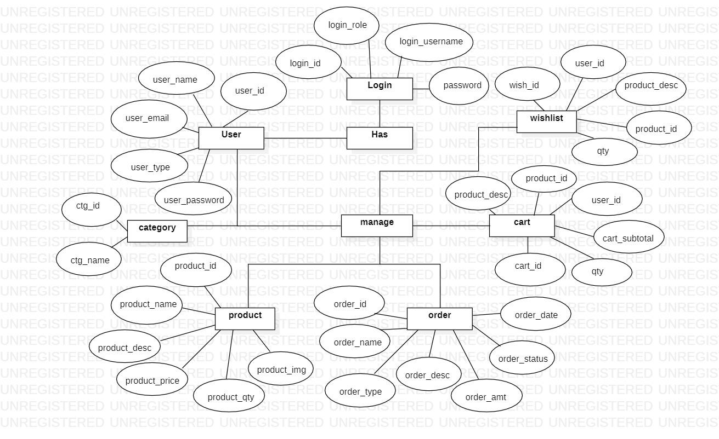

* **USE CASE DIAGRAM**

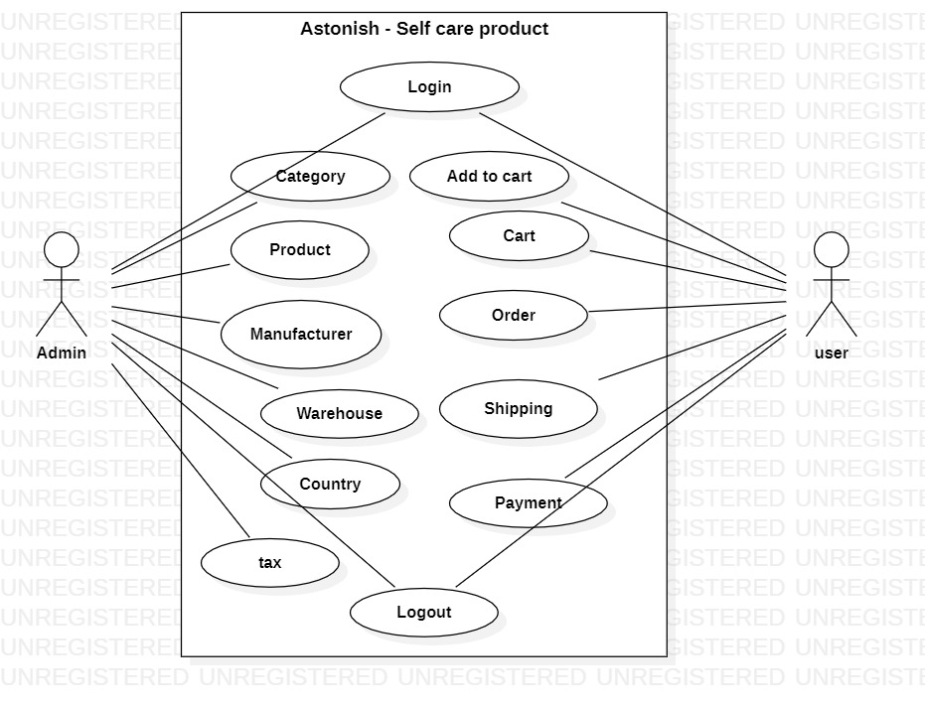

* **DATA FLOW DIAGRAM**

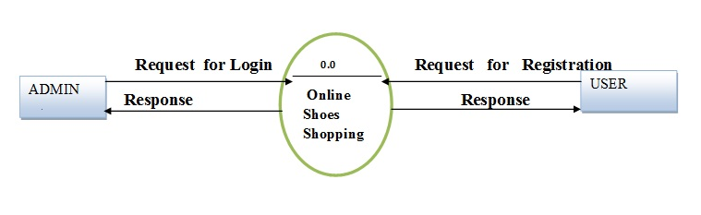

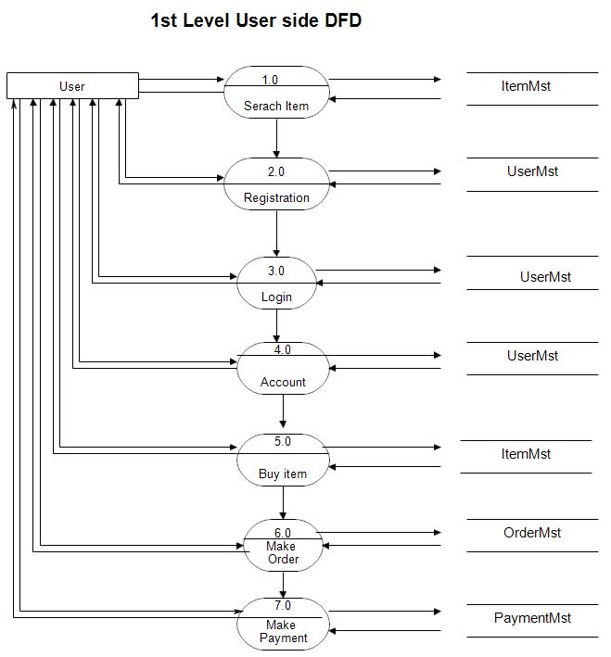

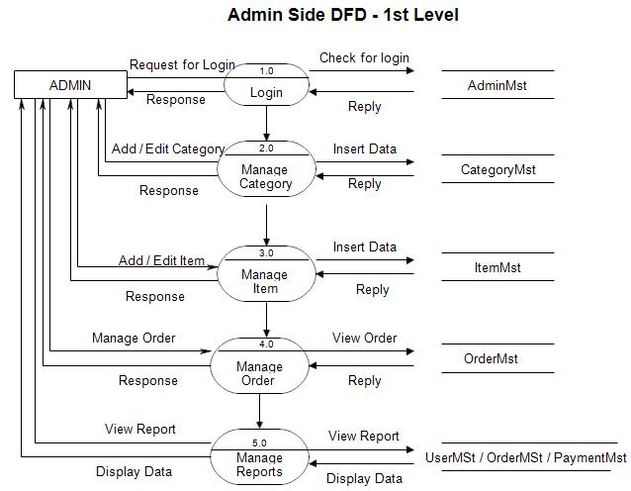

* **DATA MODELING**

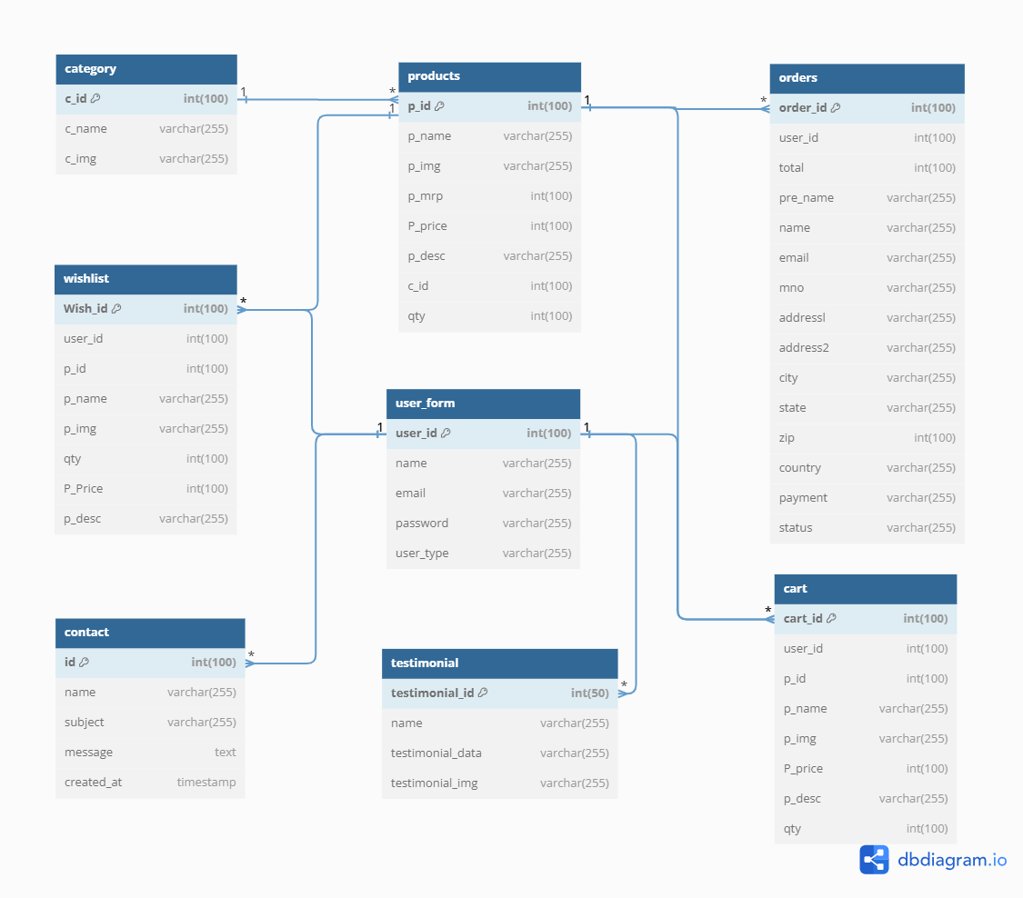

**SYSTEM DESIGN**

* **FLOW CHART**

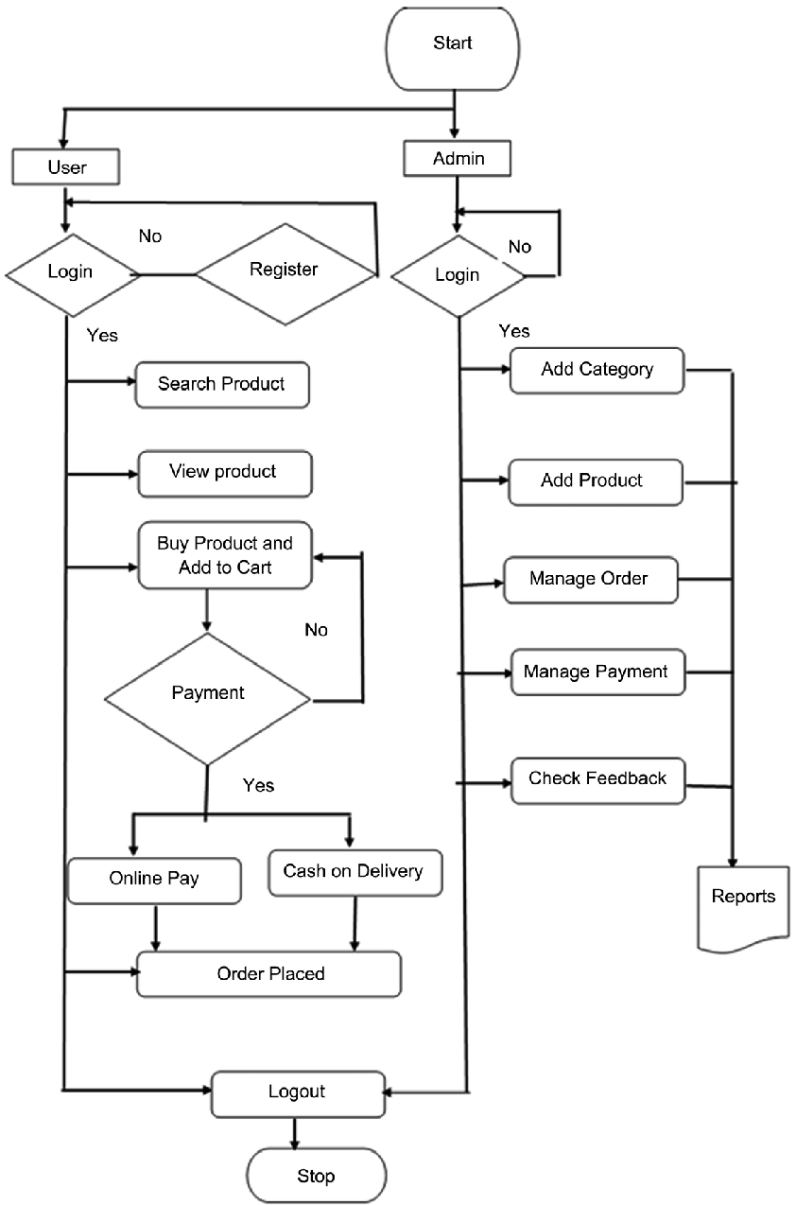

**TESTING**

* **TEST PLAN**

**1. User Registration and Login:**

Test user registration with valid and invalid data (correct and incorrect email formats, password strength, etc.).

Verify that users can log in with correct credentials and are denied access with incorrect ones.

Test password reset functionality.

**2. Product Browsing:**

Ensure that users can browse products by category and filter them based on different attributes.

Verify that product details, images, prices, and descriptions are displayed accurately.

**3. Shopping Cart and Checkout:**

Add products to the cart and verify that the cart updates correctly.

Test the cart's ability to handle multiple quantities and variations.

Proceed through the checkout process, ensuring that user details and selected items are accurately transferred.

**4. Payment Processing:**

Simulate payment transactions with valid and invalid payment information.

Verify that payment gateways process payments correctly.

Confirm that users receive payment confirmation after successful transactions.

**5. Order Management:**

Test order history to ensure that users can view their past orders.

Verify that users receive order confirmation emails.

Test the cancellation of orders and the related inventory adjustments.

**6. Navigation:**

Verify that users can navigate between different pages of the site seamlessly.

**7. User Experience:**

Test the site's responsiveness on various devices and screen sizes.

Verify that the site's design elements (buttons, forms, etc.) are consistent and aesthetically pleasing.

**8. Security and Privacy:**

Test for vulnerabilities like SQL injection, cross-site scripting (XSS), and cross-site request forgery (CSRF).

Ensure that user data (personal information, payment details) is handled securely and encrypted.

**9. Performance:**

Test the site's loading times on different pages and under various user loads.

Use tools to analyze page speed and optimize performance.

**10. Compatibility:**

Test the site on different web browsers (Chrome, Firefox, Safari, Edge) to ensure cross-browser compatibility.

Verify that the site functions on both desktop and mobile devices.

**11. Social Integration:**

Test sharing products or reviews on social media platforms.

Ensure that social media links are functional.

**12. Error Handling:**

Test error messages for user-friendliness and accuracy.

Verify that users are provided with clear instructions on how to resolve errors.

Remember that these are just examples of test cases. Depending on your site's specific functionalities, you may need to create additional test cases to cover all aspects thoroughly. Automated testing tools can also be used to streamline the testing process and ensure consistent results.

* **TESTING STRATEGY**

Developing a testing strategy for your PHP e-commerce Beauty Product Kanku website is essential to ensure that the site functions reliably and provides a seamless user experience. A comprehensive testing strategy involves different types of testing to cover various aspects of the site's functionality, performance, security, and user experience. Here's a testing strategy outline:

**1. Unit Testing:**

Test individual components, functions, and methods in isolation.

Use testing frameworks like PHP Unit for PHP to automate unit testing.

Ensure that each unit of code works as expected and handles different scenarios.

**2. Integration Testing:**

Test the interaction between different components, modules, and services.

Verify that integrated parts of the system work together seamlessly.

Address issues related to data flow, communication, and compatibility.

**3. Functional Testing:**

Test the core functionalities of the e-commerce site, including user registration, product browsing, cart management, and checkout.

Verify that users can perform tasks without encountering errors or inconsistencies.

**4. User Experience (UX) Testing:**

Test the site's usability and user-friendliness.

Verify that navigation is intuitive, and users can complete tasks with minimal effort.

Ensure consistent design, branding, and visual elements across the site.

**5. Performance Testing:**

Conduct load testing to assess how the site performs under different levels of user traffic.

Measure response times, page load times, and server resource utilization.

Optimize the site's performance based on testing results.

**6. Security Testing:**

Perform security testing to identify vulnerabilities like SQL injection, cross-site scripting (XSS), and cross-site request forgery (CSRF).

Ensure that user data and payment information are handled securely.

Implement measures to protect against attacks and breaches.

**7. Compatibility Testing:**

Test the site on various web browsers (Chrome, Firefox, Safari, Edge) and devices (desktop, tablet, mobile).

Ensure that the site functions correctly and displays properly on different platforms.

**8. Regression Testing:**

Conduct regression testing after making changes to the codebase or adding new features.

Verify that existing functionalities still work as intended and that new changes haven't introduced unexpected issues.

**9. User Acceptance Testing (UAT):**

Invite a group of real users to test the site and provide feedback.

Gather insights into the user experience and identify any issues that might have been overlooked.

**10. Accessibility Testing:**

Test the site's accessibility for users with disabilities.

Ensure compliance with accessibility standards (e.g., WCAG) to provide an inclusive experience

**11. End-to-End Testing:**

Test the complete user journey from landing on the site to completing a purchase.

Verify that all components, integrations, and interactions work seamlessly together.

**12. Data Integrity Testing:**

Test the accuracy and consistency of data stored in databases.

Verify that data is properly saved, retrieved, and updated throughout the site.

**13. Performance Tuning:**

Based on performance testing results, optimize the site's performance by tweaking configurations, caching, and resource allocation.

By implementing this comprehensive testing strategy, you can identify and resolve issues early in the development process, ensuring that your PHP e-commerce Beauty Product Kanku website is reliable, secure, and user-friendly when it's launched.

* **TESTING METHODS**

Testing methods are the specific techniques and approaches you use to execute the testing activities outlined in your testing strategy. Here are various testing methods you can employ for your PHP e-commerce Beauty Product Kanku website:

**1. Manual Testing:**

Testers manually interact with the site as users would, performing various tasks and verifying expected behavior.

Useful for exploratory testing, ad-hoc testing, and testing scenarios that are difficult to automate.

**2. Automated Testing:**

Use testing tools and scripts to automate repetitive and systematic testing tasks.

Efficient for regression testing, load testing, and large-scale testing.

**3. Black Box Testing:**

Testers focus on testing the external behavior of the site without knowledge of its internal code.

Validate that the site's features and functionalities work as expected.

**4. White Box Testing:**

Testers have access to the internal code and use this knowledge to design test cases.

Ensure code coverage and verify that the logic and structure are sound.

**5. Smoke Testing:**

Conduct basic tests to quickly check if the site's core functionalities are working after each build.

Useful for identifying critical issues early in the development cycle.

**6. Regression Testing:**

Re-test the entire system after code changes to ensure that new updates don't break existing functionalities.

Helps maintain system stability as new features are added.

**7. Exploratory Testing:**

Testers explore the site and use their intuition to identify issues that might not be covered by scripted tests.

Useful for uncovering unexpected usability or functionality issues.

**8. Load Testing:**

Simulate heavy user loads to assess the site's performance under stress.

Identify bottlenecks and optimize performance for a large number of concurrent users.

**9. Security Testing:**

Identify vulnerabilities in the site's security by attempting to exploit common weaknesses.

Focus on finding and fixing potential entry points for attacks.

**10. Usability Testing:**

Involve actual users to assess the site's ease of use, navigation, and overall user experience.

Gather feedback to improve user-friendliness.

**11. Compatibility Testing:**

Test the site across different browsers, devices, and operating systems to ensure consistent functionality.

Address any issues related to cross-browser compatibility.

**12. Performance Testing:**

Measure the site's responsiveness, speed, and resource usage to ensure optimal performance.

Optimize loading times and minimize latency.

**13. Accessibility Testing:**

Verify that the site is accessible to users with disabilities, adhering to accessibility standards like WCAG.

Test screen readers, keyboard navigation, and alternative text for images.

**14. User Acceptance Testing (UAT):**

Involve end-users to validate that the site meets their requirements and expectations.

Collect feedback on usability and functionality to make final refinements.

**15. Alpha and Beta Testing:**

Alpha testing involves internal testing before the site is released to a select group.

Beta testing involves a wider audience testing a pre-release version of the site to gather user feedback.

Each testing method serves a specific purpose and helps uncover different types of issues. Combining multiple testing methods in your testing strategy ensures a comprehensive evaluation of your PHP e-commerce Beauty Product Kanku website’s functionality, performance, and user experience.

* **TESTING CASES**

Testing cases are specific scenarios or situations that you test to ensure the functionality and reliability of your PHP e-commerce Beauty Product Kanku website. Here are some example testing cases for various aspects of your e-commerce site:

**1. User Registration and Login:**

a. Test user registration with valid data.

b. Test user registration with invalid email formats.

c. Test user registration with weak passwords.

d. Verify email confirmation upon registration.

e. Test user login with correct credentials.

f. Test user login with incorrect credentials.

g. Test password reset functionality.

**2. Product Browsing:**

a. Test product browsing by category.

b. Test product filtering by attributes (e.g., price range, brand).

c. Verify that product details display accurately.

d. Test product image display and zoom functionality.

e. Test product search functionality.

**3. Shopping Cart and Checkout:**

a. Add products to the cart.

b. Test cart update with quantity changes.

c. Test cart item removal.

d. Proceed through the checkout process with valid data.

e. Proceed through the checkout process with invalid or missing information.

f. Verify order summary and total.

**4. Payment Processing:**

a. Test payment processing with valid payment information.

b. Test payment processing with invalid payment information.

c. Verify payment confirmation and receipt.

d. Test payment gateway error handling.

**5. Order Management:**

a. Test order history display for registered users.

b. Verify order confirmation emails are sent to users.

c. Test order cancellation and inventory updates.

d. Verify order status updates (processing, shipped, delivered).

**6. Search and Navigation:**

a. Test search functionality with different search terms.

b. Verify that search results are relevant and accurate.

c. Test navigation between site pages (home, product, categories, user profile, cart etc.).

**7. User Experience (UX) Testing:**

a. Test site responsiveness on various devices (desktop, tablet, mobile).

b. Verify consistent design elements and branding.

c. Test page load times and performance.

**8. Security and Privacy:**

a. Test for security vulnerabilities (SQL injection, XSS, CSRF, etc.).

b. Ensure secure handling of user data and payment information.

c. Verify data encryption during transmission.

**9. Performance Testing:**

a. Conduct load testing with simulated user traffic.

b. Measure server response times under different loads.

c. Optimize performance based on test results.

**10. Compatibility Testing:**

a. Test the site on various browsers (Chrome, Firefox, Safari, Edge).

b. Test on different operating systems.

c. Verify cross-browser compatibility.

**11. Accessibility Testing:**

a. Test screen reader compatibility.

b. Verify keyboard navigation.

c. Ensure alternative text for images and proper use of ARIA roles.

**12. Usability Testing:**

a. Involve users to assess the site's ease of use.

b. Gather feedback on navigation, layout, and user-friendliness.

**13. Social Integration:**

a. Test sharing products or reviews on social media platforms.

b. Verify the functionality of social media links.

**14. Error Handling:**

a. Test error messages for clarity and accuracy.

b. Verify that users receive guidance on resolving errors.

**15. Order Fulfillment:**

a. Test the order processing workflow from order placement to shipping.

b. Verify that shipping addresses are correct.

c. Test email notifications for order updates.

These testing cases cover a wide range of scenarios to ensure that your PHP e-commerce Beauty Product Kanku website functions correctly, securely, and provides a positive user experience. Depending on the complexity of your site and specific features, you may need to create additional test cases.

**DATA DICTIONARY**

**cart**

|  |  |  |  |  |
| --- | --- | --- | --- | --- |
| Field Name | Data Type | Field Length | Constraint | Description |
| cart_id | int | 100 | AUTO_INCREMENT  Primary Key | Cart id |
| user_id | int | 100 | NOT_NULL | User id |
| p_id | Int | 100 | NOT_NULL | Product id |
| p_name | varchar | 255 | NOT_NULL | Product name |
| p_img | varchar | 255 | NOT_NULL | Product image |
| P_price | int | 100 | NOT_NULL | Product price |
| p_desc | varchar | 255 | NOT_NULL | Product description |
| qty | Int | 100 | NOT_NULL | Quantity |

**category**

|  |  |  |  |  |
| --- | --- | --- | --- | --- |
| Field Name | Data Type | Field Length | Constraint | Description |
| c_id | Int | 100 | AUTO_INCREMENT Primary Key | Category id |
| c_name | Varchar | 255 | NOT_NULL | Category name |
| c_img | Varchar | 255 | NOT_NULL | Category image |

**contact**

|  |  |  |  |  |
| --- | --- | --- | --- | --- |
| Field Name | Data Type | Field Length | Constraint | Description |
| Id | Int | 100 | AUTO_INCREMENT Primary Key | Contact id |
| name | varchar | 255 | NOT_NULL | Contact name |
| subject | varchar | 255 | NOT_NULL | Contact subject |
| message | text | - | NOT_NULL | Contact message |
| created_at | timestamp | - | NOT_NULL | Created date |

**user_form**

|  |  |  |  |  |
| --- | --- | --- | --- | --- |
| Field Name | Data Type | Field Length | Constraint | Description |
| user_id | int | 100 | AUTO_INCREMENT Primary Key | User id |
| name | varchar | 255 | NOT_NULL | User name |
| email | varchar | 255 | NOT_NULL | User email |
| password | varchar | 255 | NOT_NULL | User password |
| user_type | varchar | 255 | NOT_NULL | User type |

**testimonial**

|  |  |  |  |  |
| --- | --- | --- | --- | --- |
| Field Name | Data Type | Field Length | Constraint | Description |
| testimonial_id | int | 50 | AUTO_INCREMENT Primary Key | Testimonial id |
| name | varchar | 255 | NOT_NULL | Testimonial name |
| testimonial_data | varchar | 255 | NOT_NULL | Testimonial data |
| testimonial_img | varchar | 255 | NOT_NULL | Testimonial image |

**products**

|  |  |  |  |  |
| --- | --- | --- | --- | --- |
| Field Name | Data Type | Field Length | Constraint | Description |
| p_id | int | 100 | AUTO_INCREMENT Primary Key | Product id |
| p_name | varchar | 255 | NOT_NULL | Product name |
| p_img | varchar | 255 | NOT_NULL | Product image |
| p_mrp | int | 100 | NOT_NULL | Product MRP |
| P_price | int | 100 | NOT_NULL | Product price |
| p_desc | varchar | 255 | NOT_NULL | Product description |
| c_id | int | 100 | NOT_NULL | Category id |
| qty | int | 100 | NOT_NULL | Quantity |

**orders**

|  |  |  |  |  |
| --- | --- | --- | --- | --- |
| Field Name | Data Type | Field Length | Constraint | Description |
| order_id | int | 100 | AUTO_INCREMENT Primary Key | Order id |
| user_id | int | 100 | NOT_NULL | User id |
| total | int | 100 | NOT_NULL | Total bill amount |
| pre_name | varchar | 255 | NOT_NULL | Prefix or title |
| name | varchar | 255 | NOT_NULL | Customer name |
| email | varchar | 255 | NOT_NULL | Customer email |
| mno | varchar | 255 | NOT_NULL | Mobile number |
| addressl | varchar | 255 | NOT_NULL | Order Address1 |
| address2 | varchar | 255 | NOT_NULL | Order Address2 |
| city | varchar | 255 | NOT_NULL | Order City |
| state | varchar | 255 | NOT_NULL | Order State |
| zip | int | 100 | NOT_NULL | Order Zip |
| country | varchar | 255 | NOT_NULL | Order Country |
| payment | varchar | 255 | NOT_NULL | Payment Method |
| status | varchar | 255 | NOT_NULL | Order status |

**wishlist**

|  |  |  |  |  |
| --- | --- | --- | --- | --- |
| Field Name | Data Type | Field Length | Constraint | Description |
| Wish_id | int | 100 | AUTO_INCREMENT Primary Key | Wishlist id |
| user_id | int | 100 | NOT_NULL | User id |
| p_id | int | 100 | NOT_NULL | Product id |
| p_name | varchar | 255 | NOT_NULL | Product name |
| p_img | varchar | 255 | NOT_NULL | Product image |
| qty | int | 100 | NOT_NULL | Product quantity |
| P_Price | int | 100 | NOT_NULL | Product price |
| p_desc | varchar | 255 | NOT_NULL | Product description |

**SCREEN SHOTS**

* **User Side**

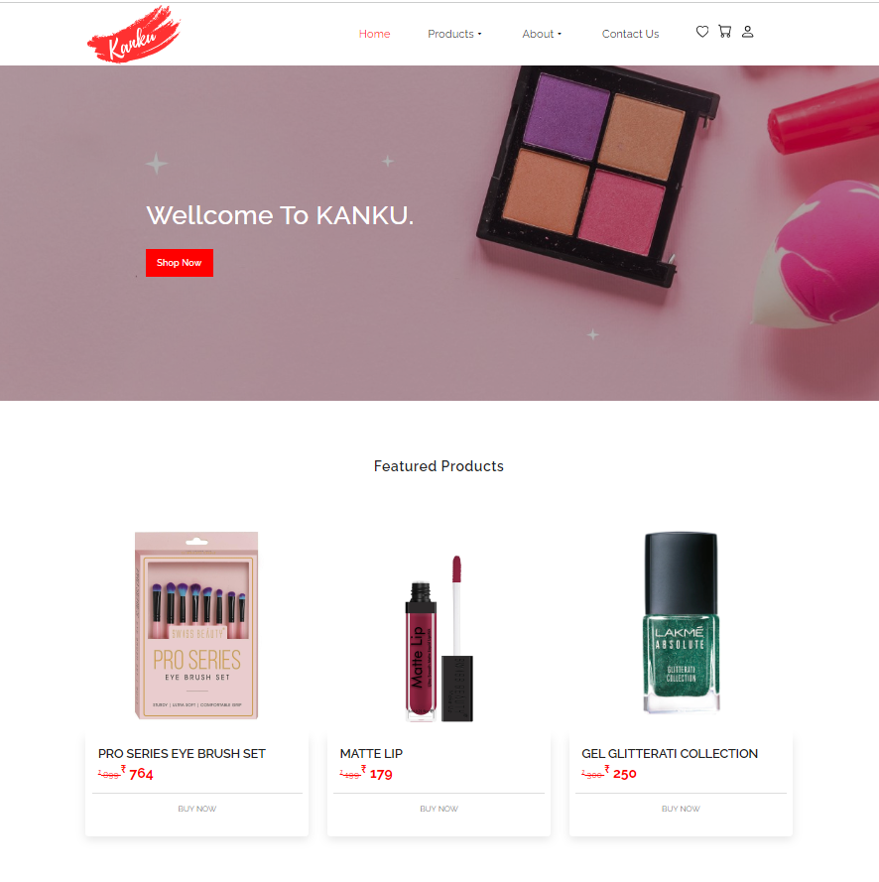

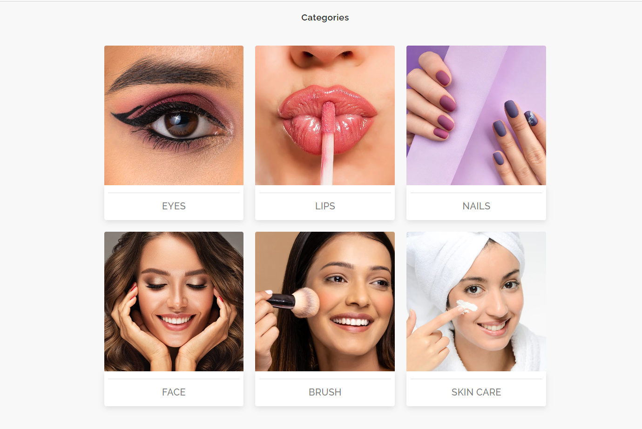

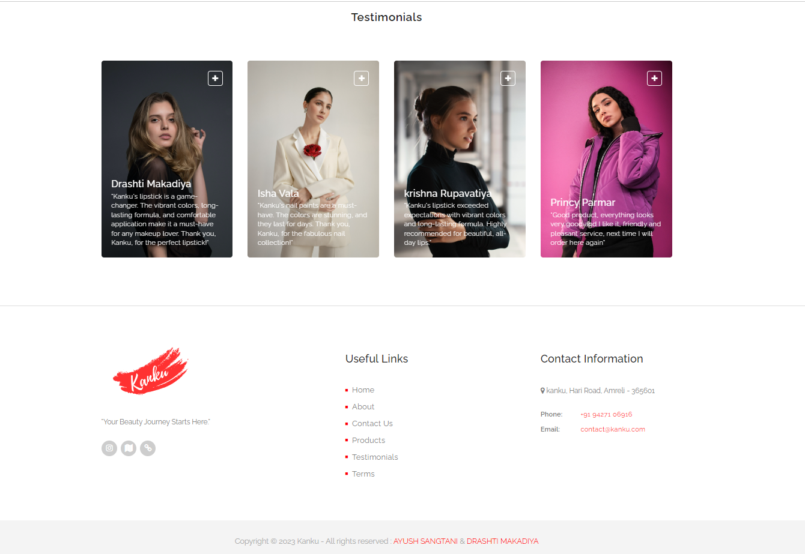

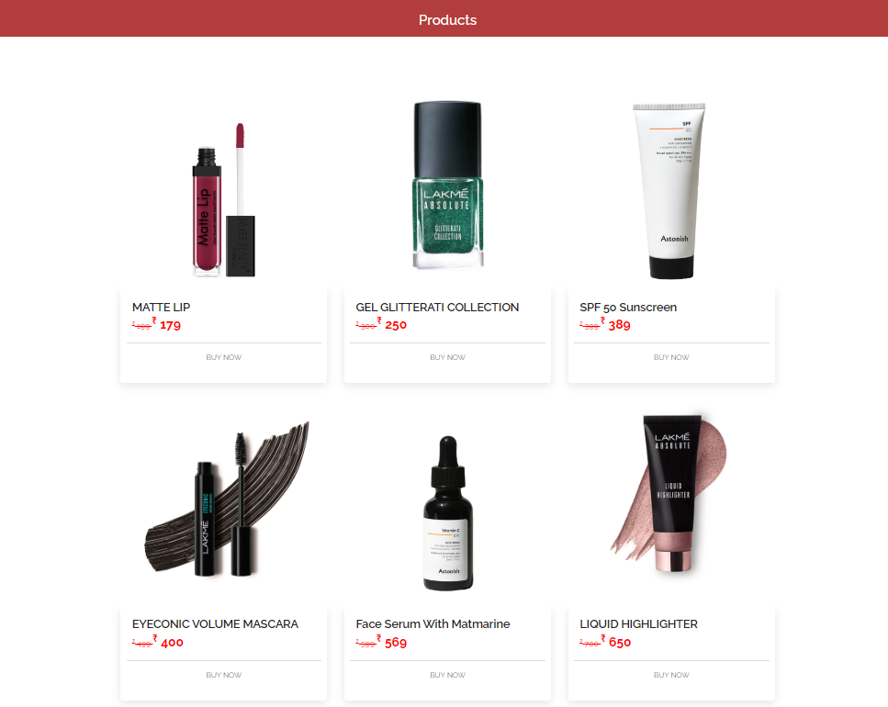

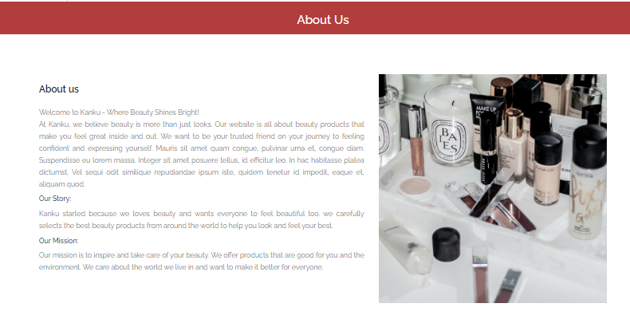



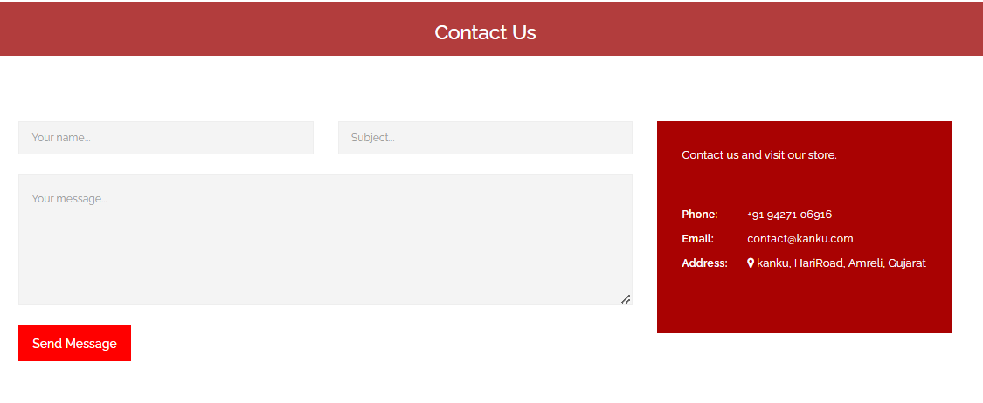

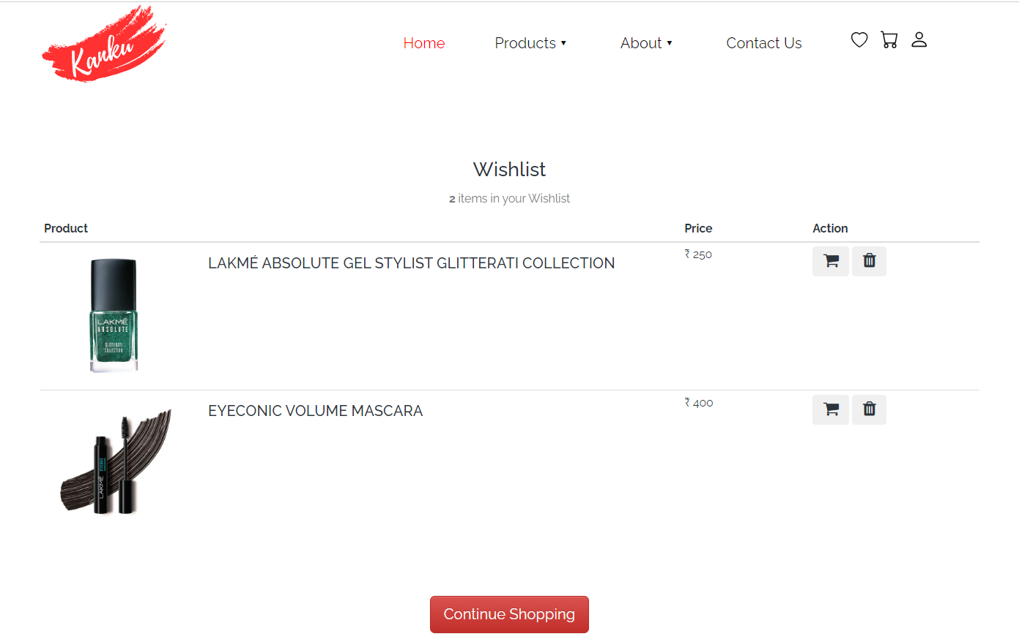

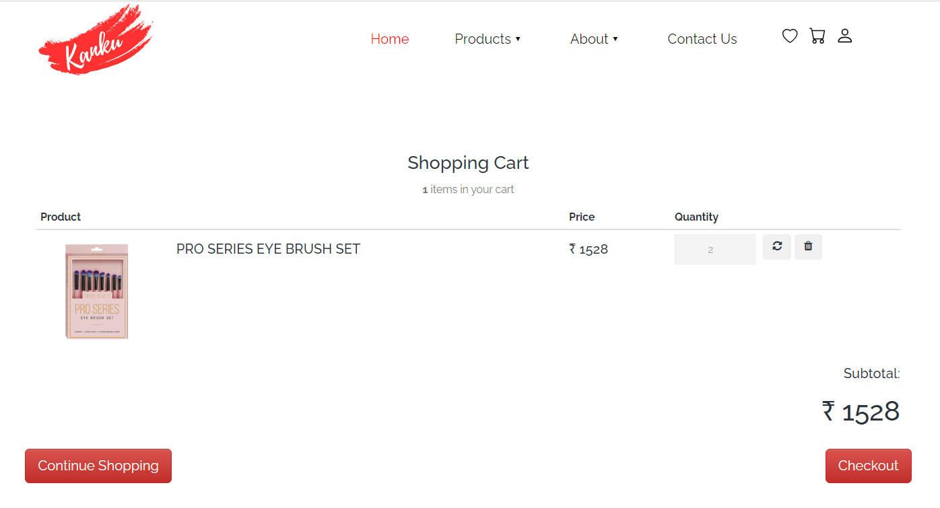

* **Admin Side**

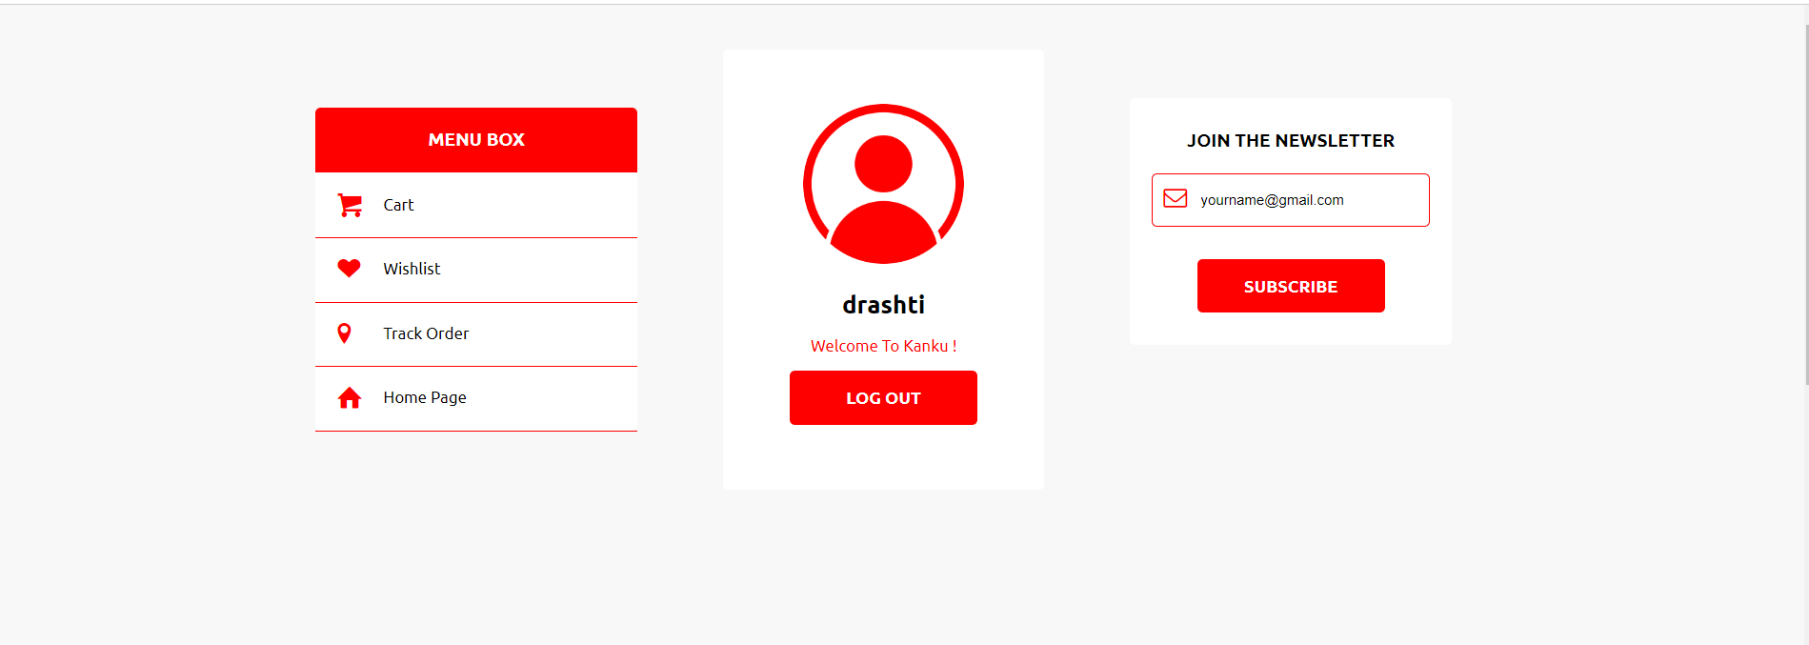

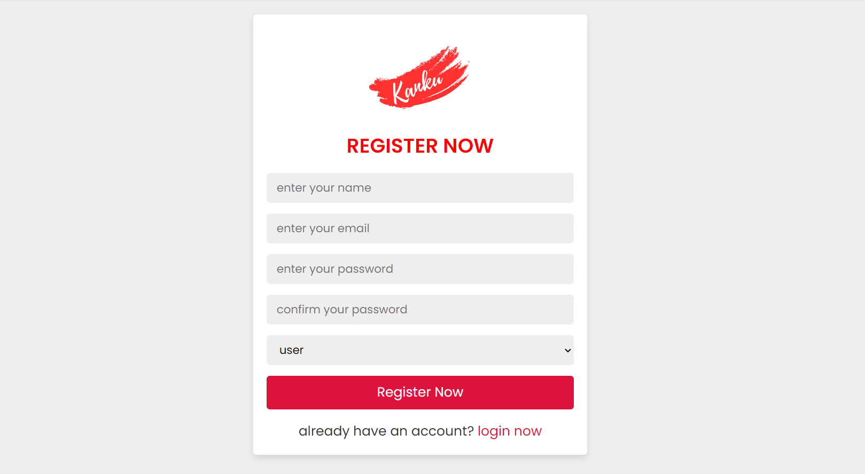

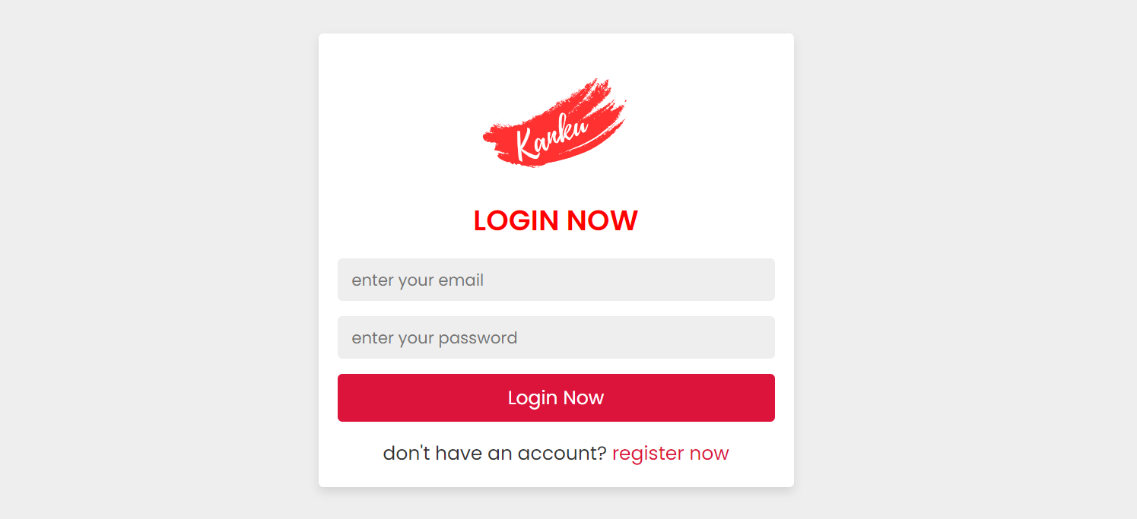

* **Admin Side**

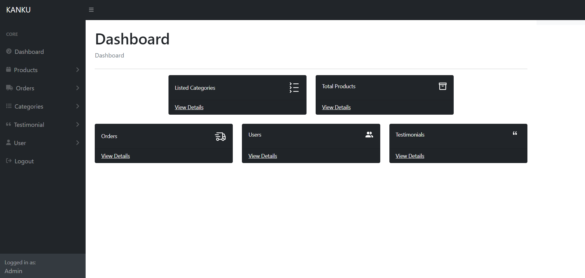

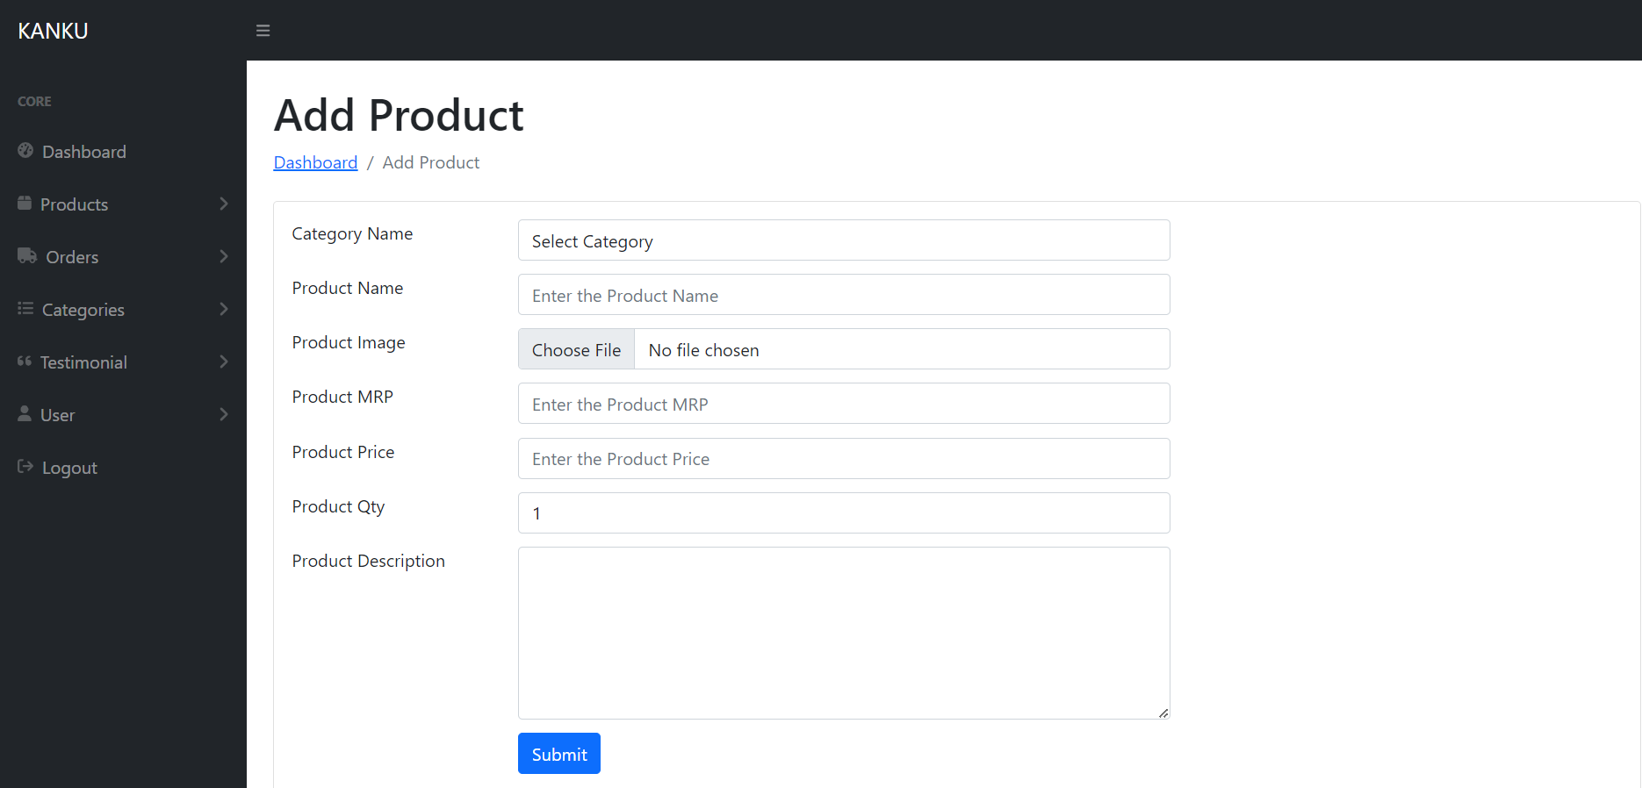

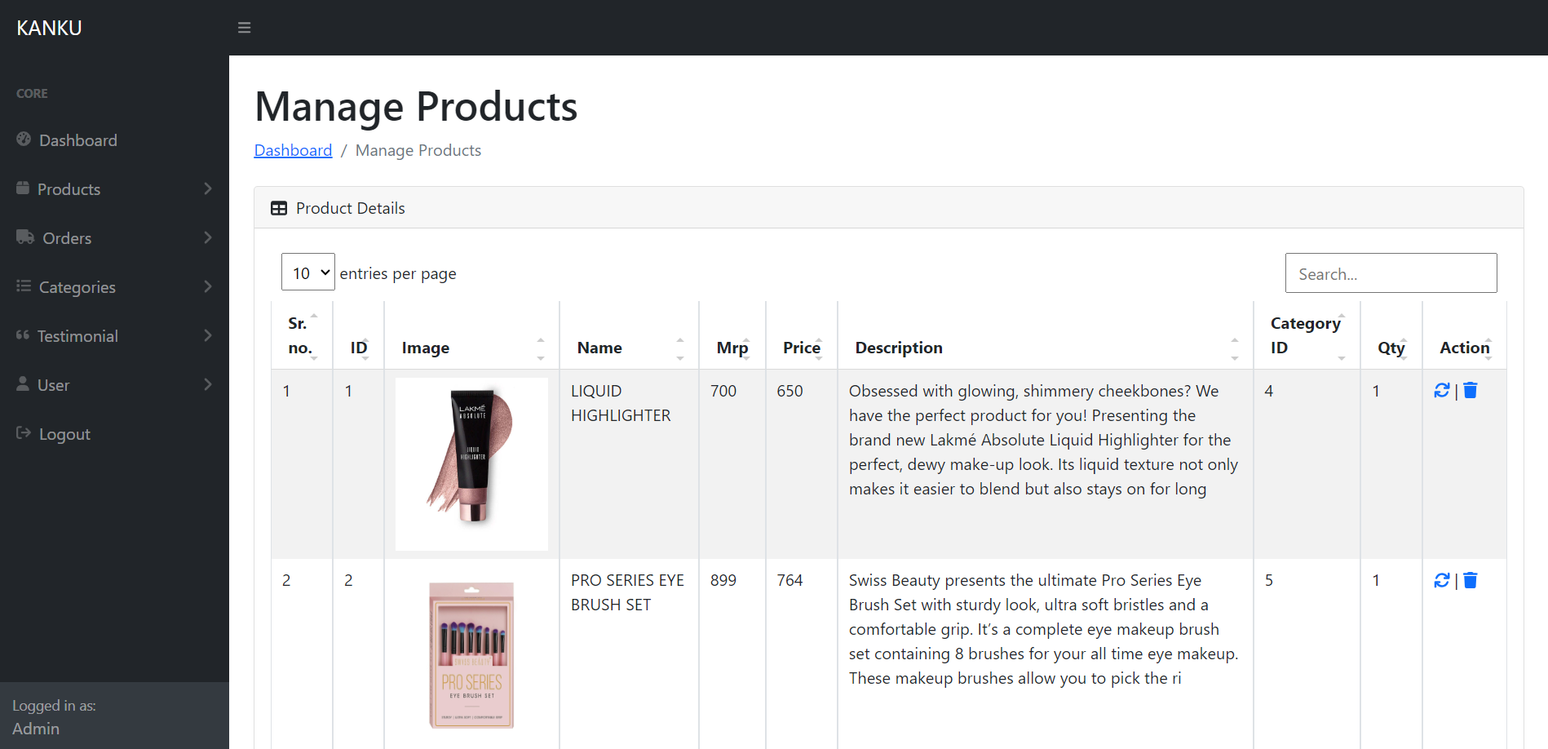

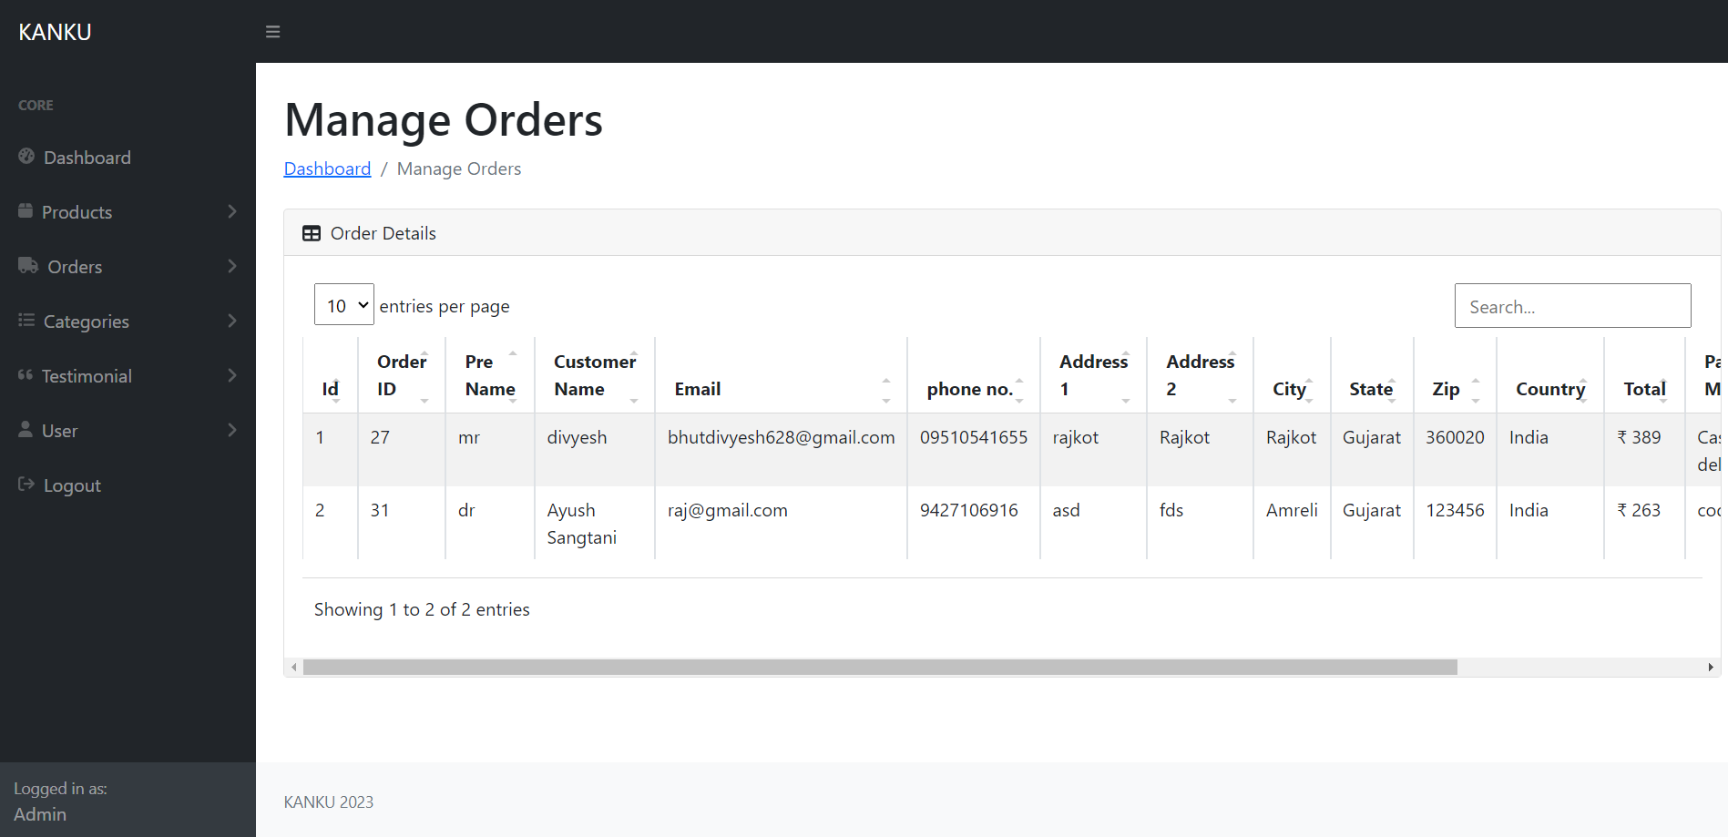

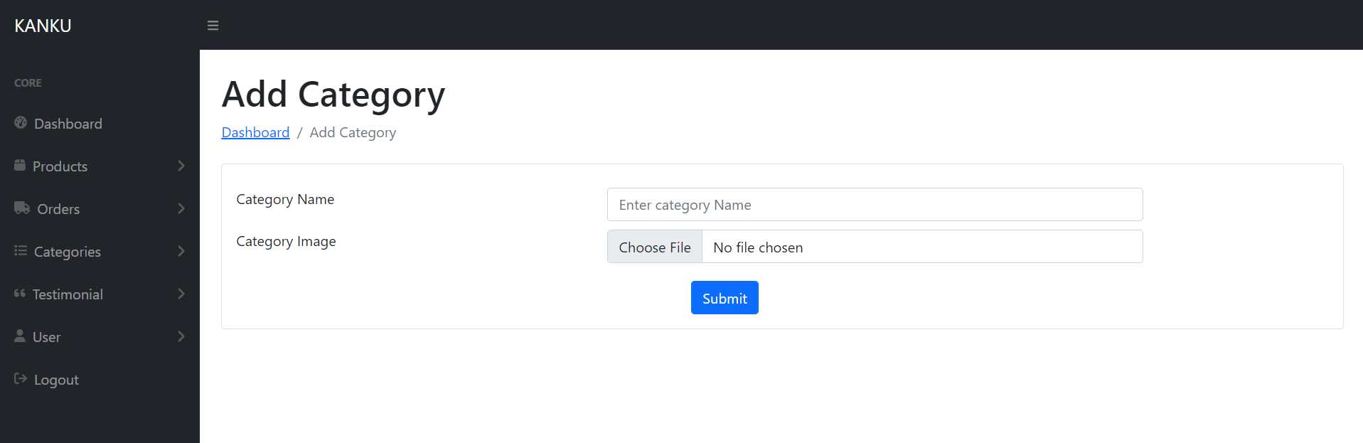

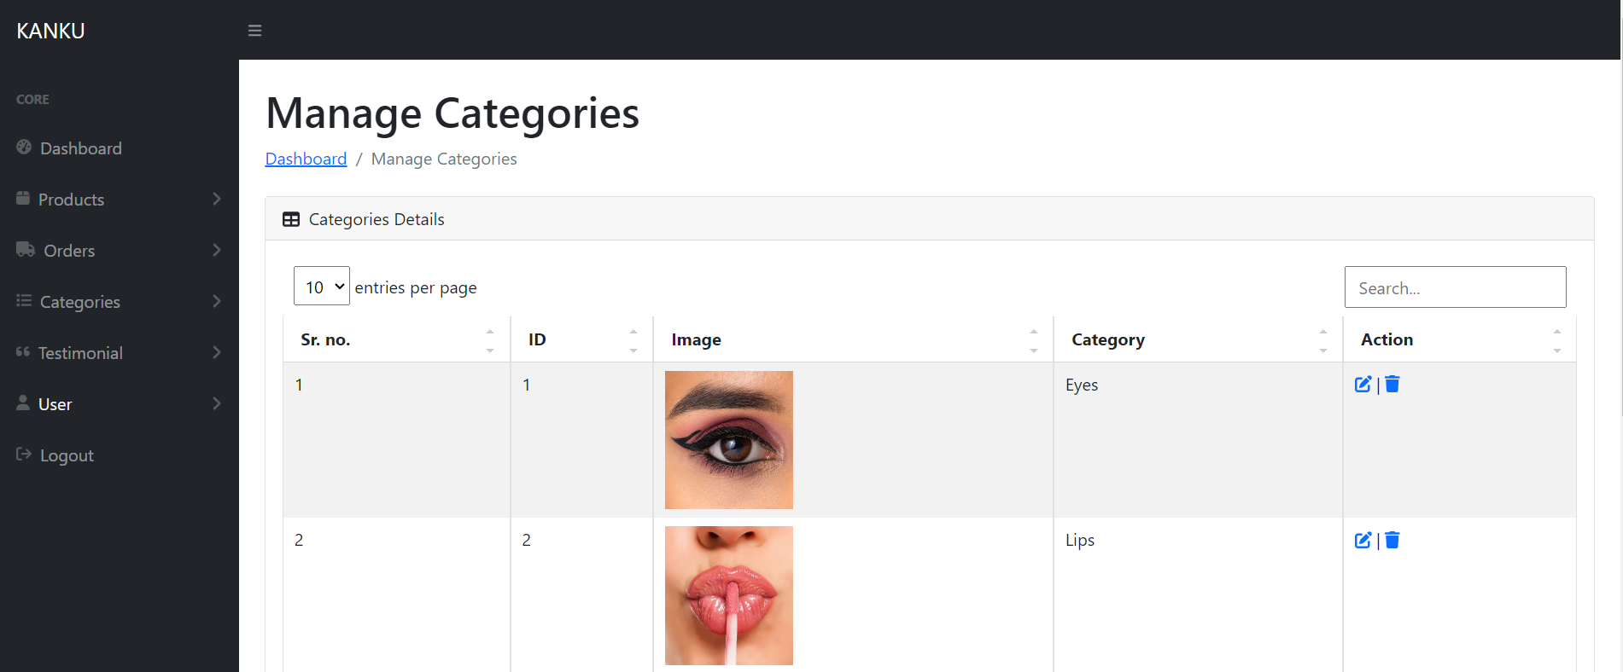

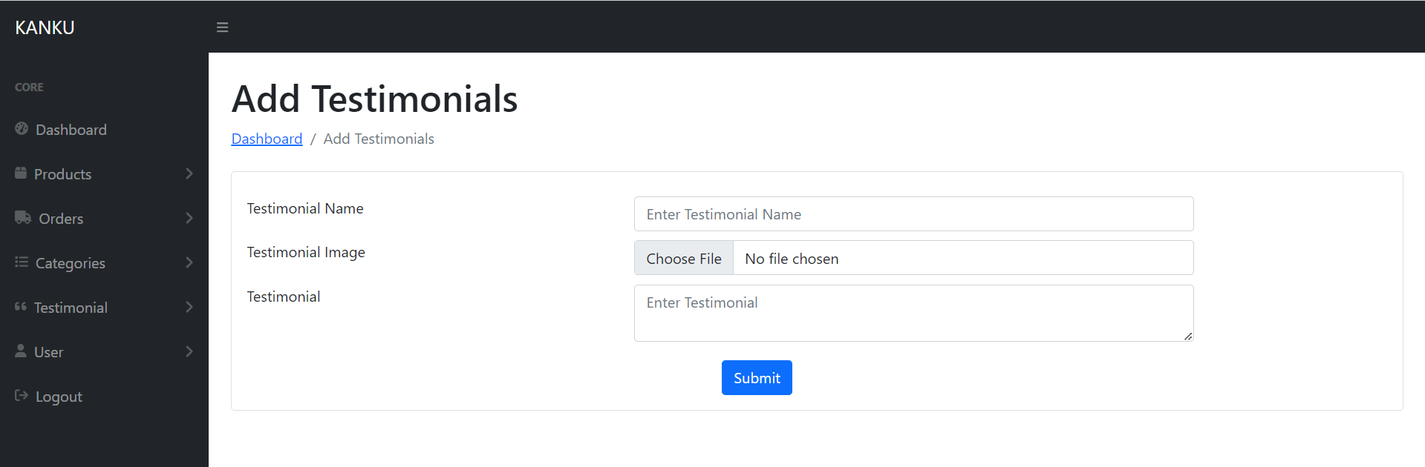

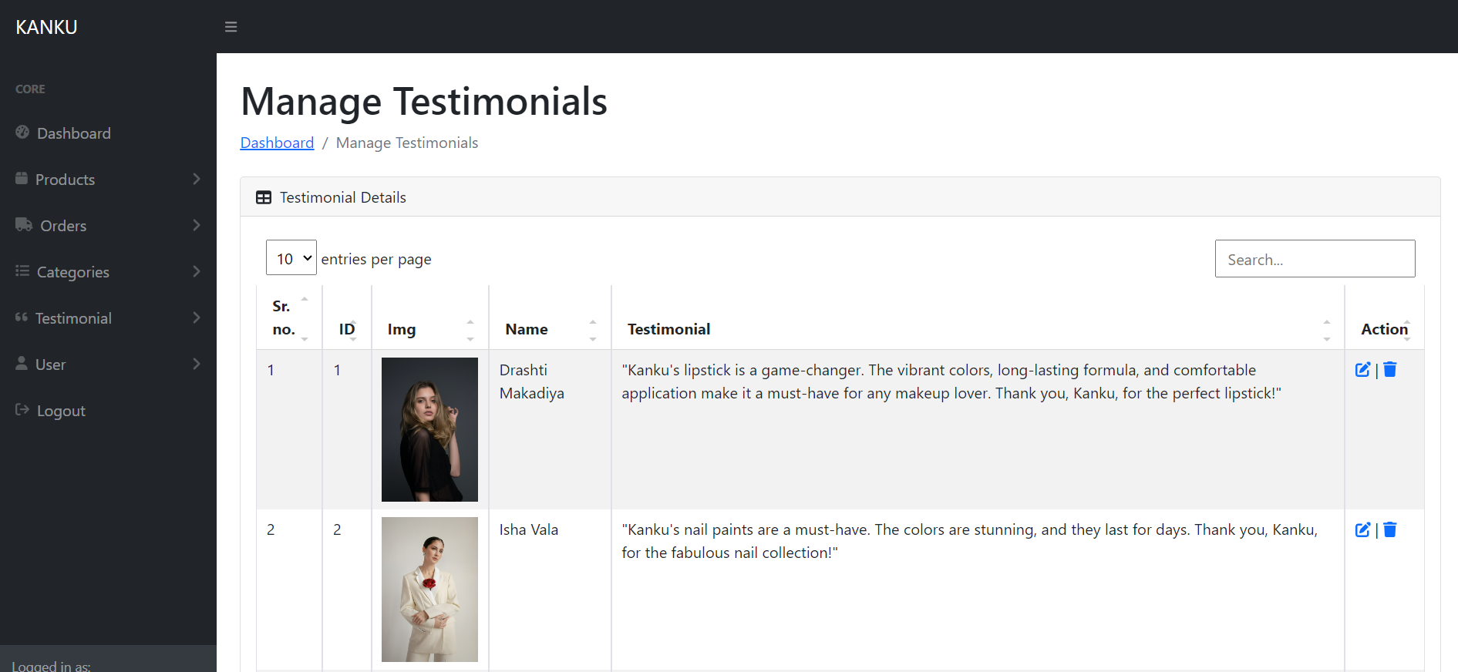

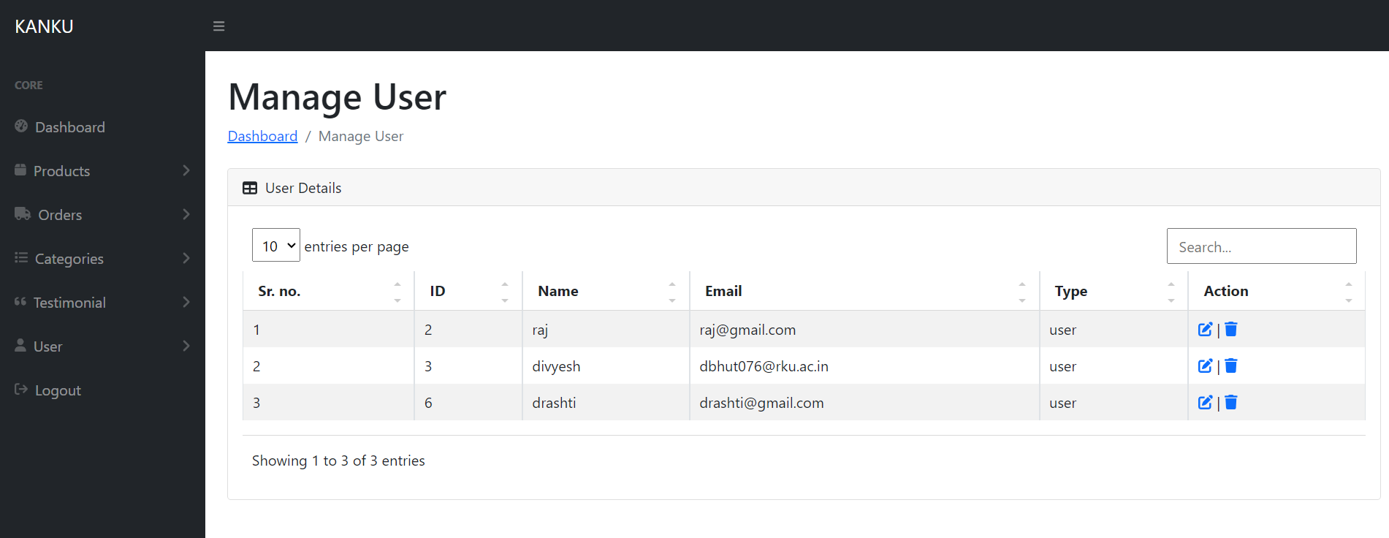

* **Database**

**Cart**

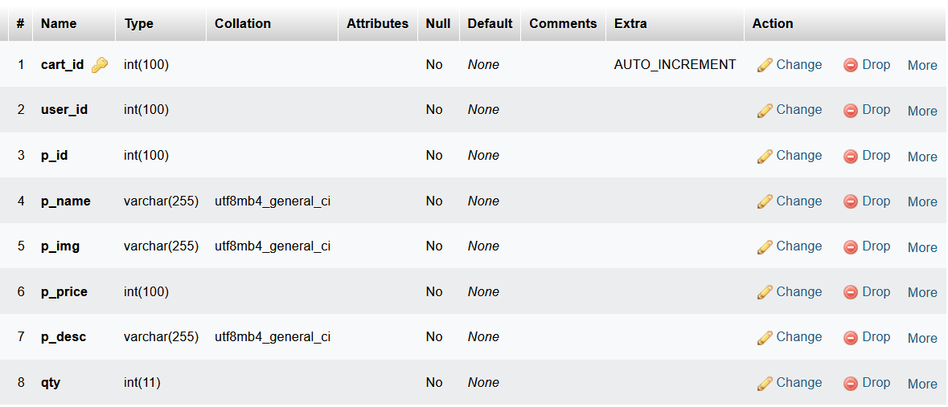

**Category**

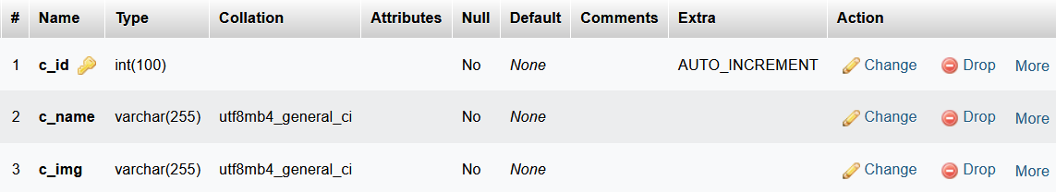

**Products**

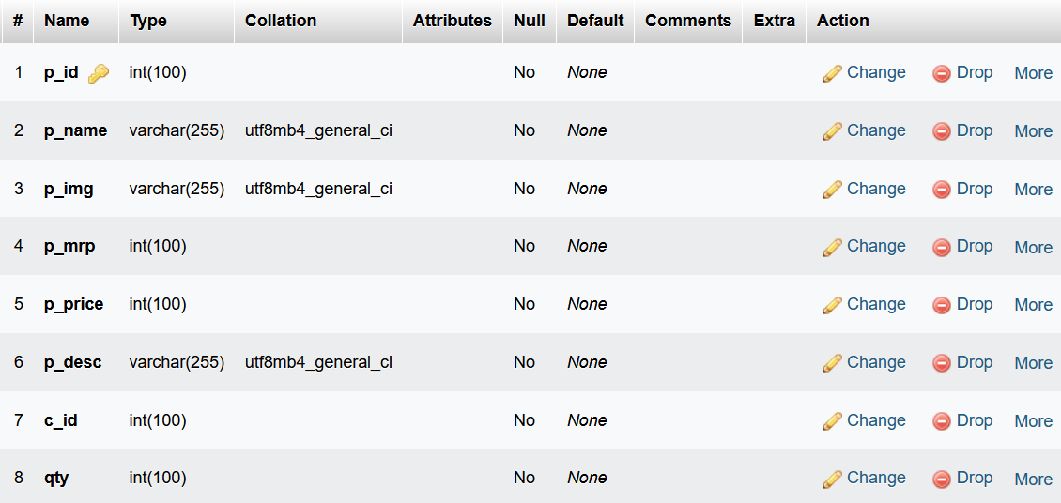

**Orders**

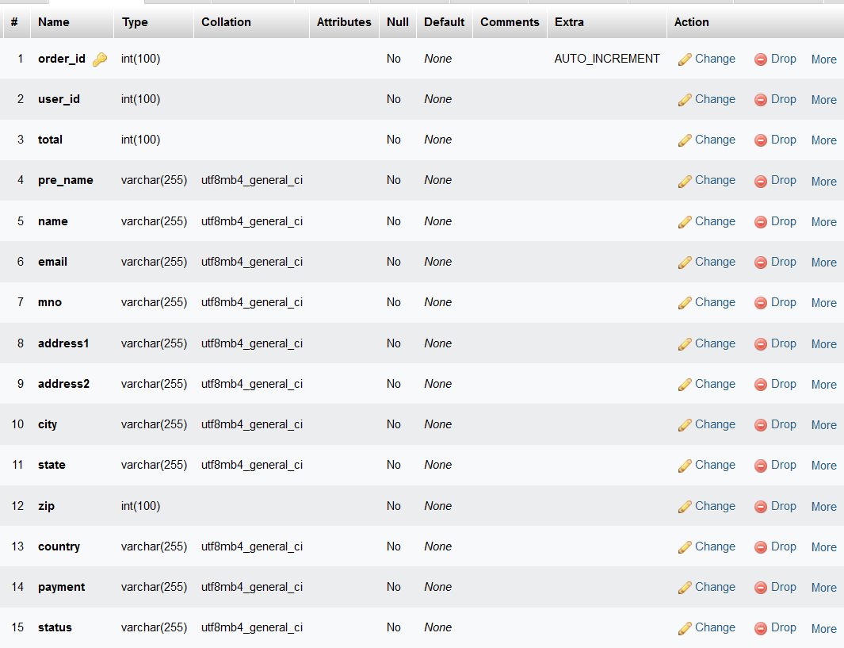

**Wishlist**

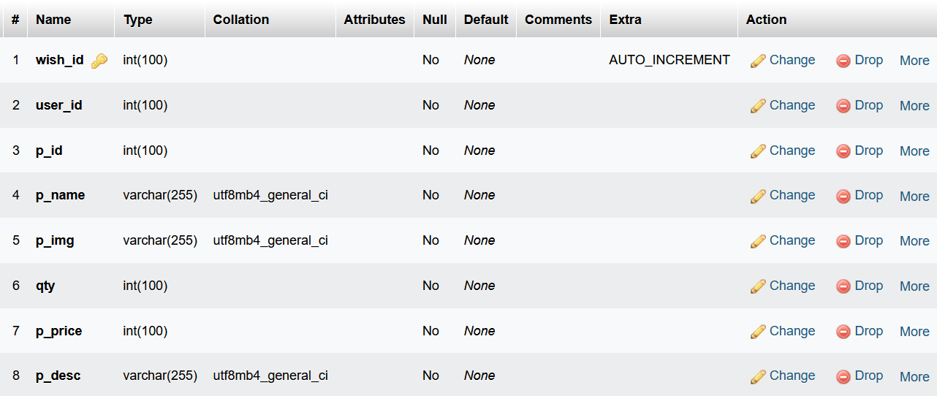

**Testimonial**

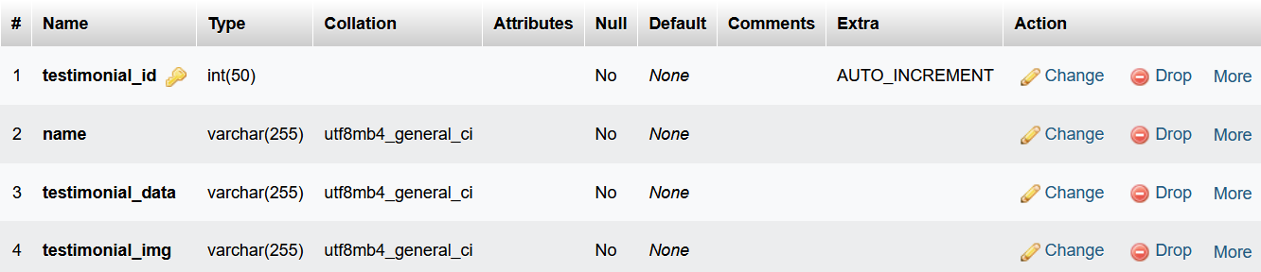

**User_form**

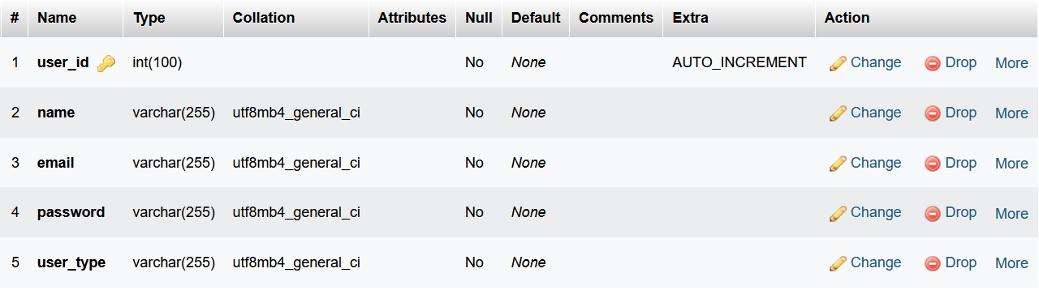

**LIMITATION & FUTURE ENHANCEMENT**

* **LIMITATION**

**Scalability:**

Limitation: The site might struggle to handle a sudden increase in user traffic during promotions or special events.

Mitigation: Implement scalable architecture and cloud-based hosting to accommodate traffic spikes.

**Limited Payment Options:**

Limitation: The site might offer a limited set of payment options, potentially turning away customers who prefer other methods.

Mitigation: Integrate additional payment gateways to provide more choices.

**Mobile Responsiveness:**

Limitation: The mobile version of the site may not offer an optimal user experience, affecting mobile users' satisfaction.

Mitigation: Invest in responsive design or a dedicated mobile app.

**Inventory Management:**

Limitation: Manual inventory updates can lead to inaccuracies and overselling.

Mitigation: Implement an automated inventory management system.

**Limited Personalization:**

Limitation: The site may not offer personalized product recommendations, potentially missing out on upsell opportunities.

Mitigation: Incorporate recommendation algorithms based on user behavior and preferences.

* **FUTURE ENHANCEMENT**

**Enhanced User Profiles:**

Enhancement: Allow users to create detailed profiles, including product preferences and wish lists.

**Advanced Search and Filtering:**

Enhancement: Improve search capabilities with filters, sorting options, and advanced search algorithms.

**Customer Reviews and Ratings:**

Enhancement: Enable customers to leave reviews and ratings for products, enhancing trust and decision-making.

**Subscription Services:**

Enhancement: Introduce subscription models for products that users can subscribe to on a regular basis.

**Multi-Language Support:**

Enhancement: Offer the site in multiple languages to reach a broader audience.

**Enhanced Analytics:**

Enhancement: Implement advanced analytics tools to gather insights into user behavior and sales trends.

**AI-Powered Chatbots:**

Enhancement: Integrate AI-driven chatbots to provide instant customer support and assistance.

**Personalized Marketing:**

Enhancement: Implement email marketing campaigns tailored to individual user preferences and behaviors.

**Enhanced Security:**

Enhancement: Continuously monitor and enhance security measures to protect user data and transactions.

**Expand Product Catalog:**

Enhancement: Continuously add new product categories and expand the range of products available.

**Augmented Reality (AR):**

Enhancement: Implement AR features that allow users to visualize products in their own environment before purchase.

**Blockchain Integration:**

Enhancement: Explore blockchain technology for enhanced security and transparency in transactions.

**Sustainability Initiatives:**

Enhancement: Promote and integrate sustainability initiatives, such as eco-friendly product options and carbon offset programs.

**Voice Commerce:**

Enhancement: Enable voice-activated shopping for users with smart devices.

**Progressive Web App (PWA):**

Enhancement: Develop a PWA for improved offline access and performance on mobile devices.

**Community and Social Features:**

Enhancement: Build a community around the site with forums, social sharing, and user-generated content.

It's essential to prioritize these enhancements based on user feedback, market trends, and business goals. Regularly assessing and updating your site will keep it competitive and appealing to users.

**CONCLUSION AND DISCUSSION**

In conclusion, the development of a PHP e-commerce Beauty Product Kanku website presents a promising opportunity to tap into the growing market for beauty and skin-care and wellness products. This project involves creating a user-friendly and secure platform where users can discover, purchase, and engage with beauty and skin-care products. Throughout the discussion and planning stages, we've explored various aspects of this project, including its purpose, features, technologies, and testing strategies.

* **DISCUSSION**

Purpose: The primary purpose of this e-commerce site is to provide users with a convenient and engaging platform to explore and purchase beauty and skin-care products. It aims to offer a wide range of products, from skincare and wellness items to personal development and relaxation tools.

Technologies: We've considered the use of HTML, CSS, and PHP for site development, ensuring a responsive design and dynamic functionality. Additionally, we discussed the importance of a robust database management system (e.g., MySQL) and server hosting.

Testing Strategies: To ensure the site's reliability and user-friendliness, we outlined a comprehensive testing strategy that covers various aspects, including functionality, security, performance, and user experience. This strategy includes manual testing, automated testing, and user acceptance testing.

Limitations and Future Enhancements: Every project has its limitations, such as scalability challenges, limited payment options, and potential mobile responsiveness issues. However, we've also discussed future enhancement ideas to keep the site competitive and aligned with evolving user expectations.

* **CONCLUSION**

The development of a PHP e-commerce Beauty Product Kanku Website is a dynamic and exciting endeavor. It has the potential to cater to the growing demand for beauty and skin-care products while creating a valuable platform for users to discover and purchase items that promote well-being.

To achieve success, it's essential to prioritize user experience, security, and performance throughout the development process. Regular testing and ongoing enhancements will ensure that the site remains competitive and relevant in the ever-changing e-commerce landscape.

In conclusion, this project offers the opportunity to create a user-focused, secure, and innovative e-commerce platform that contributes to users' beauty and skin-care journeys while providing a valuable business opportunity.

**REFERENCES**

* [phpjabber](https://www.phpjabbers.com/free-shopping-website-template-103.php) (templet)
* [lakme](https://www.lakmeindia.com/) (products)
* [minimilist](https://beminimalist.co/collections/skin) (products)
* [swiss-beauty](https://swissbeauty.in/) (design UI & products)
* [getbootstrap](https://icons.getbootstrap.com/) (icons)
* [phpgurukul](https://phpgurukul.com/e-diary-management-system-using-php-and-mysql/) (admin panel)
* [bootstrap](https://getbootstrap.com/docs/5.3/getting-started/introduction/)